Table of Contents

Prithvi Flood-IN: from a river-flow forecast to who goes under water
Satellite foundation models, a flood atlas and engineering impacts for the Mahanadi delta
CE Integrated Design Project, Department of Civil Engineering, IIT Bombay, 2026
Team: Nikhil Upadhyay (lead), Prakhar Gupta, Prabhat Kumar, Vineet Jangir, Himanshu Shete Faculty guide: Prof. Basudev Biswal (IIT Bombay) · Industry partner: ClimMaTech Pvt. Ltd., IIT Mandi (Dr. Vivek Gupta, CTO; Siddik Barbhuiya, lead hydrologist)

Abstract
Flood early-warning systems in India, including those of our industry partner ClimMaTech, measure and forecast the river at points (gauges on bridges and spillways), but do not show what a forecast flow floods. We address this for the Mahanadi delta below Naraj (3,038 km², 4.1 million people). First, we select a satellite water-mapping model with a controlled benchmark of six geospatial foundation models (Prithvi-EO-2.0, TerraMind, DOFA, Clay, Satlas, DeCUR) against CNN and U-Net baselines on Sen1Floods11 (92 training runs, three seeds). On a flood in India that no model saw in training (Assam 2016), U-Net reached IoU 0.770 and the best foundation model 0.747; fusing U-Net, CNN and the best-validated foundation model reached 0.776. Because monsoon floods are under cloud, the operational model is a radar-only fusion of TerraMind-B and U-Net (IoU 0.646 on 20 m radar). Applied to 590 Sentinel-1 passes from 2017 to 2026, it gives a flood atlas of the delta. Linking the atlas to GloFAS discharge at Naraj, each 20 m pixel receives the flow at which it starts to flood, so a discharge forecast becomes a flood map; on years held out from fitting, this map beats flood climatology at high flows (IoU 0.23 vs 0.07). For the 25-year flood (32,997 m³/s) about 25,163 people live on flooded land, 32 km of road is under water and 36,941 people in 32 settlements lose road access to any hospital. A learned model that adds local rain and each pixel’s flood history to the river flow maps held-out heavy-rain passes better still (IoU 0.22 against 0.17). The same scenarios are carried through seven civil-engineering specializations: hospital and shelter access and travel delay (transportation), wall failure depth and IRC:78 bridge scour (structural), river banks to inspect and ground saturation under houses that stay dry (geotechnical), Bay of Bengal storms as a flood driver (ocean), work windows, earthwork for raising critical links and a deployment schedule (construction management), and the watershed above the delta, where about half of a flood peak comes from below Hirakud dam (water resources). An audit of all 92 training runs found no problems and reproduces the published TerraMind scores within a point. We provide a forecast-to-bulletin tool with CAP alerts, a map viewer and project website, and a field protocol that measures what the models cannot know (accuracy at random points, discharge and roughness, bridge clearance, bank soils, well levels).
Keywords: flood mapping, Sentinel-1, geospatial foundation models, TerraMind, Prithvi, U-Net, Mahanadi, impact-based flood warning, road network, river-bank screening

Team and contributions
Member | Specializations | What they built | Report | At the site
Nikhil Upadhyay (lead) | Water resources, Ocean | Flow-to-flood model, rain analogs, design floods and travel time, Saint-Venant PINN; storm drivers; field-visit organisation and WRD/CWC contacts | §5, §6.3–6.5, §7.6 | Discharge, slope, Manning’s n (B, C); WRD/CWC interviews
Vineet Jangir | Remote sensing | Benchmark of six foundation models against CNN and U-Net (92 runs), fusion, radar model for 20 m input | §4, §6.1 | Ground-truth points (A)
Prakhar Gupta | Remote sensing | Flood atlas from all Sentinel-1 passes, Sentinel-2 cross-check, map viewer | §6.1–6.2 | Ground-truth points, GPS and photo log (A)
Himanshu Shete | Transportation systems, Structural | Road-network model (hospital and shelter access, travel delay, critical links), flood depth, wall and IRC:78 scour checks; integration of the impact chain, forecast-to-bulletin tool, project website, report and slides | §7.1–7.3, §9.1–9.2 | Bridge inspections, foundation levels, road closures (D); evening data runs
Prabhat Kumar | Geotechnical, Construction technology and management | Bank screening, ground-saturation advisory, foundation and drawdown checks; work windows, earthwork, deployment quantities and schedule; siren and sensor siting | §7.4–7.5, §7.7, §9.3–9.4 | Bank inspection, soil samples and lab tests, well levels, site sheets (E, F, H)

1. Introduction

1.1 The problem in the field
ClimMaTech, the project’s industry partner (IIT Mandi), builds flood early-warning systems: non-contact radar gauges on bridges and dam spillways (Pravaah, Tarang), edge-AI camera nodes (Doordrishti), solar sirens (Rakshak), a control-room web application and the Aagah mobile app. Their architecture lists a “River View” layer, a map-based view of river levels and flood risk. Every product measures or forecasts the river at a point: the level and flow at a gauge, 30 minutes to 48 hours ahead. None of them shows what that flow means on the ground: which land, villages, roads, bridges and embankments go under water. Their own case study of the 26 August 2026 Nepal–China flood compares a 1-D Saint-Venant model with flood widths measured on Sentinel-2 images, which is exactly the link between satellite water maps and hydraulics that this project builds.
The Mahanadi delta below Naraj (Cuttack, Kendrapara, Jagatsinghpur; about 4.1 million people in our 3,038 km² study box) is the most flood-exposed reach of the Mahanadi basin, where Prof. Basudev Biswal’s long-running basin work, the Hirakud–Naraj flood operations of the Odisha Water Resources Department and the Central Water Commission’s gauges all meet. The IDP review of 14 October asked us to connect one fine-tuned foundation model to such a real project, to go to the site with a purpose, and to bring in the other civil-engineering disciplines that a river project involves.
Refined problem statement. For the Mahanadi delta, turn a river-flow forecast at Naraj into a map of what floods and whom it affects, using a satellite foundation model selected by a fair benchmark, and use that map to plan where warnings and sensors should go. Concretely we
- select a satellite water-mapping model by benchmarking six geospatial foundation models against CNN and U-Net baselines, including on a flood in India that the models never saw (§4);
- run it on every Sentinel-1 radar pass over the delta from 2017 to 2026 (monsoon and dry season) to build a flood atlas, and check it against Sentinel-2 images taken within a day (§6);
- link the atlas to river discharge at Naraj, so that a discharge forecast becomes an inundation map, and test that link on years it was not fitted on (§6);
- translate inundation into engineering impacts: people and buildings, roads and bridges (transportation and structures), river banks (geotechnical) (§7);
- plan siren and river-sensor sites for a ClimMaTech-type deployment (§9); and
- check and calibrate all of this with measurements and interviews at the site (§8).

1.2 Stakeholders
Stakeholder | Role in the problem | What they need from this work | What we need from them
ClimMaTech (Dr. Vivek Gupta, CTO; Siddik Barbhuiya, lead hydrologist) | Industry partner; sensors, sirens, forecasts | A flood-extent layer and village list per forecast; sensor and siren siting | Product constraints (siren range, data formats), site-survey practice
Prof. Basudev Biswal’s Mahanadi basin project (IIT Bombay) | The sanctioned real project | Inundation maps and impacts for the delta | Site access, introductions to engineers
Odisha Water Resources Dept., CWC Mahanadi division | Embankments, Naraj/Mundali barrages, gauges | Which banks and roads fail at which flow | Observed discharge, embankment inventory, breach history
OSDMA, district administrations (Cuttack, Kendrapara, Jagatsinghpur) | Warnings, evacuation, shelters | Villages to warn per forecast; cut-off roads | Evacuation records, shelter list
Villages and farmers in the delta | Flooded every few years | Earlier, local warnings | What actually flooded, when and how deep

1.3 Where the project stood at mid-term
At mid-term (5 October 2026) the team had fine-tuned the published Prithvi-EO-2.0 Sen1Floods11 checkpoint on 3,584 Indian chips built from NDEM flood maps. Test IoU on 16 unseen Indian events rose from 0.337 to 0.375. The review of that work (mid-term meeting) raised five problems that this second half addresses directly:
- The absolute scores were far below the benchmark (IoU ≈ 0.68–0.71 for Sen1Floods11 models), which pointed to problems in how the Indian chips and masks were built rather than in the model.
- There was no from-scratch baseline, so the value of the foundation model was not isolated.
- Only optical data were used, although monsoon floods happen under cloud.
- One training run per model, so run-to-run noise was unknown. (The mentor notebook itself shows ±0.02 IoU for the same U-Net, same data, same seed.)
- The mentors’ new plan (7 October): every team member takes one foundation model, all models are trained on a common dataset, compared zero-shot and fine-tuned, and then fused into one model.
The NDEM-based Indian dataset lives on a team member’s Google Drive and was not available on the lab server used for this phase. All new experiments therefore use Sen1Floods11, the dataset of the mentor notebook, with two protocols designed to answer the Indian question honestly (Section 2.2).

1.4 Objectives of this phase
No. | Objective | Discipline | Answered in
F1 | Compare six foundation-model families against from-scratch and no-training baselines under one identical recipe | AI / remote sensing | §4.1
F2 | Measure performance on a flood event the models have never seen in India | AI / remote sensing | §4.2
F3 | Separate what pre-training gives for free (frozen encoder) from what fine-tuning adds | AI / remote sensing | §4.3
F4 | Fuse the models (“fuse layer”) and test whether the fusion beats the best single model | AI / remote sensing | §4.4
F5 | Decide whether radar, optical or both are needed (monsoon cloud) | remote sensing | §4.5
F6 | Calibrate thresholds; errors by event and by permanent vs flood water; label efficiency | AI / remote sensing | §4.6–4.7
F7 | PINN track: verify, reproduce, complete the residual exercise, retrain | hydraulics | §5
F8 | Flood atlas of the Mahanadi delta 2017–2026 with an independent optical check | remote sensing, hydrology | §6.1–6.2
F9 | Discharge-to-inundation model at Naraj, tested on held-out years; design floods | hydrology | §6.3–6.5
F10 | Exposure; hospital and shelter access, everyday travel delay and critical links | transportation systems | §7.1–7.2
F11 | Flood depth, masonry-wall screening, bridge scour (IRC:78) and clearance (IRC:5) | structural | §7.3
F12 | River-bank screening; ground saturation under houses that stay dry; foundation and slope checks | geotechnical | §7.4–7.5
F13 | Bay of Bengal storms as a flood driver | ocean | §7.6
F14 | Work windows, earthwork for raising critical links, deployment quantities and schedule | construction technology & management | §7.7
F15 | Field visit: measure, ask, and feed the results back into the models | all | §8
F16 | Siren and river-sensor siting; forecast-to-bulletin tool; integration with the ClimMaTech platform | construction planning | §9

2. Data

2.1 Sen1Floods11 (hand-labelled subset, v1.1)
446 chips of 512 × 512 pixels (~5 km × 5 km at 10 m) from 11 flood events. Each chip has Sentinel-2 L1C (13 bands, top-of-atmosphere reflectance × 10⁴), Sentinel-1 GRD (VV, VH, σ⁰ in dB), a hand label (1 water, 0 dry, −1 unknown), and the JRC permanent-water layer. The archive downloaded on the lab server matches the published checksum (SHA-256 d836b0c9…640a4f).
The labels mark all surface water during the flood, including normal rivers and lakes (96.4 % of JRC permanent-water pixels are labelled water). Section 4.6 therefore also scores every model on non-permanent water only, which is closer to “flood”.
Our audit of the cache (results/audit.json):
Event | Chips | Water share of labelled pixels | Unknown share | Permanent share of water
India (Assam, 12 Aug 2016) | 68 | 12.4 % | 16.0 % | 19.5 %
USA | 69 | 4.6 % | 2.4 % | 33.0 %
Paraguay | 67 | 8.4 % | 5.0 % | 33.5 %
Ghana | 53 | 6.3 % | 33.8 % | 12.6 %
Sri Lanka | 42 | 11.8 % | 9.5 % | 69.2 %
Mekong | 30 | 24.1 % | 9.3 % | 28.6 %
Spain | 30 | 13.2 % | 1.7 % | 39.5 %
Pakistan | 28 | 7.5 % | 26.7 % | 18.9 %
Somalia | 26 | 6.5 % | 21.1 % | 0.0 %
Nigeria | 18 | 23.5 % | 14.3 % | 8.4 %
Bolivia (held-out) | 15 | 15.9 % | 27.1 % | 6.6 %
Missing measurements: 2.2 % of radar pixels are NaN and 2.1 % of optical pixels are 0.

2.2 Two evaluation protocols
Protocol | Train | Validation | Test | What it measures
Official | 252 chips (10 events incl. 40 India) | 89 | 90 (all 10 events) | Comparable with published numbers; test events were also seen in training
Leave-India-out (LIO) | 212 chips (9 events, no India) | 75 (no India) | all 68 India chips | A flood the model has never seen, in India: Assam / Brahmaputra, Aug 2016
Both protocols also report the official Bolivia hold-out (15 chips, an event never in any training set). The LIO protocol follows the caution in our data kit: the official split puts the single Indian event in train, validation and test, so its “India score” is not an unseen-event score.

2.3 Mahanadi delta: satellite archive and context layers (no flood labels)
The study box is the central delta around Cuttack–Kendrapara (85.80–86.45 °E, 20.25–20.65 °N, 3,038 km²; one UTM 45N grid at 10 m for single events and 20 m for the atlas). All sources are open and need no login.
Layer | Source | Use
Sentinel-1 RTC γ⁰ (VV, VH), every pass in Feb–Mar and Jun–Nov, 2017 – Oct 2026, three tracks (descending 48 and 121, ascending 85), Sentinel-1A/B/D | Microsoft Planetary Computer, sentinel-1-rtc | flood atlas (§6)
Sentinel-2 L2A (B03, B11, scene classification) within ±1 day of a radar pass | Planetary Computer, sentinel-2-l2a | independent optical check (§6.2)
JRC Global Surface Water occurrence 1984–2021 | Planetary Computer, jrc-gsw | normal rivers and lakes
River discharge, daily, Naraj / Tikarpara / below Hirakud, 1984–2026 | GloFAS v4 reanalysis via the Open-Meteo flood API | discharge-to-inundation model, design floods
Rainfall, daily, mean of 6 points over the delta, 2016–2026 | ERA5 via the Open-Meteo archive API | second flood driver (§6.4)
Population 2020 (3″ grid) | JRC GHSL GHS-POP R2023A | people exposed, settlements
Building footprints | Microsoft Global ML Building Footprints (incomplete here: ~120 k) | mapped buildings exposed
Land cover 2021 | ESA WorldCover (Planetary Computer) | farmland, built-up
Elevation | Copernicus GLO-30 DEM (Planetary Computer) | context
Soil sand / silt / clay, 0–30 cm | ISRIC SoilGrids 2.0 (250 m) | bank screening (§7.4)
Roads (with node ids), railways, waterways | OpenStreetMap via Overpass | network analysis, bridges
Places, hospitals and clinics, schools, embankments, shelters | OpenStreetMap, Geofabrik eastern-India extract (the Overpass servers were overloaded) | destinations, names
Cyclone and depression tracks, North Indian Ocean, 1980–2025 | IBTrACS v4 (NOAA NCEI) | storm drivers (§7.6), work windows (§7.7) |
Basin areas: Hirakud catchment about 83,400 km², whole Mahanadi basin about 141,600 km² | published figures (sources differ by about 2 %) | watershed view (§7.8) |
Optical images on the large flood dates were 61–95 % cloud over the box, so the atlas uses radar only.

2.4 Software, compute and data volume
Item | What was used
Deep learning | PyTorch with TerraTorch (IBM) for the foundation-model backbones; a common decoder and training loop in floodfm/
Geospatial | rasterio, GDAL, pyproj, geopandas, pyogrio, scipy (Dijkstra on the road graph, image morphology), pystac-client for the Planetary Computer catalogue
Statistics and learning on tables | scikit-learn (logistic-regression fusion layer, gradient-boosted flood model, ROC AUC), pandas, numpy
Maps and documents | matplotlib, Leaflet 1.9.4 (map viewer), pandoc / python-docx / python-pptx (report and slides)
Compute | IIT Bombay lab server: 2 GPUs, 32 CPU cores, 62 GB memory; the benchmark cache sat in RAM because the data disks are slow
Data volume | Sen1Floods11 hand-labelled set 446 chips; Mahanadi radar archive 590 passes at 20 m (about 11 GB); atlas probability maps about 1.7 GB
Run times | one benchmark run 10–40 minutes; one radar pass mapped in about 5 s on one GPU; atlas build about 26 minutes; impact chain about 5 minutes; learned flood model about 27 minutes on 28 cores

3. Methods

3.1 One pipeline for every model
All models read chips through the same code (floodfm/), so differences in scores come from the models:
- Inputs: 13 Sentinel-2 bands + VV, VH. Prithvi uses the six HLS bands it was pre-trained on (B02, B03, B04, B8A, B11, B12); Satlas and DeCUR are optical-only by design; TerraMind, DOFA and Clay receive optical and radar.
- Normalisation: each band is standardised with the model’s own pre-training statistics where they are published (TerraMind, Prithvi), otherwise with statistics of the training split. Missing pixels are replaced by the band mean before standardising, so they become exactly 0. (The mentor notebook filled missing VH with the VV mean, which becomes 1.31 after standardising.)
- Training recipe (identical for all): full 512 × 512 chips; random rotations/flips (D4); loss = cross-entropy + soft Dice on the water class with unknown pixels ignored; AdamW with 2-epoch warm-up and cosine decay; 40 epochs; batch 8; bf16. Learning rates: 10⁻³ for from-scratch models; 5 × 10⁻⁵ for pre-trained encoders and 3 × 10⁻⁴ for the new decoder.
- Model selection: the epoch with the best validation water IoU. Test chips are used once, after training.
- Seeds: every fine-tuned model is trained with seeds 0, 1, 2 under both protocols; tables give mean ± standard deviation.
- Metric: water IoU (TP / (TP + FP + FN)) over labelled pixels, pooled over all test chips; also F1, precision, recall, mean per-chip IoU and per-event IoU.

3.2 Models
Group | Model | Parameters | Pre-training | Inputs used
No training | Otsu threshold on VH | 0 | — | S1 VH
No training | NDWI > 0, MNDWI > 0 | 0 | — | S2 green/NIR, green/SWIR1
No training | Prithvi-EO-2.0-300M-TL-Sen1Floods11 (published) | 324 M | HLS MAE + Sen1Floods11 fine-tune by IBM/NASA | 6 S2 bands
From scratch | Simple CNN (3 conv) | 0.02 M | none | 15 bands
From scratch | U-Net (4 levels, 32 base channels) | 7.8 M | none | 15 bands
Foundation | Prithvi-EO-2.0-300M (ViT-L) | 324 M | masked autoencoder on global HLS | 6 S2 bands
Foundation | TerraMind-v1-base (ViT-B) | 103 M | multimodal generative, S1+S2+DEM+LULC… | 13 S2 + 2 S1
Foundation | DOFA-base (ViT-B) | 128 M | wavelength-conditioned MAE, optical + SAR | 13 S2 + 2 S1
Foundation | Clay-v1-base (ViT-B) | 108 M | wavelength-aware MAE, multi-sensor | 13 S2 + 2 S1
Foundation | Satlas Swin-v2-B | 93 M | SatlasPretrain, Sentinel-2 multispectral | 13 S2
Foundation | SSL4EO-S12 DeCUR ResNet-50 | 35 M | contrastive (DeCUR), Sentinel-2 | 13 S2
The four ViT encoders feed four of their layers through a learned feature pyramid into the same UNet-style decoder (channels 512-256-128-64); the hierarchical encoders (Swin, ResNet) feed their four stages into the same decoder type. Every model outputs two logits per pixel.
Frozen vs fine-tuned. “Zero-shot” in the strict sense is impossible for Prithvi, DOFA, Clay, Satlas and DeCUR: they are encoders and output features, not water masks. We therefore report two modes: frozen encoder (only the decoder is trained — what the pre-trained features already know) and full fine-tune. The published Prithvi flood checkpoint is the one true zero-shot model.

3.3 Fusion (“fuse layer”)
Fusion combines models of the same seed and is fitted on validation predictions only. Three member sets are used: the six fine-tuned foundation models; all eight trained models (the six plus CNN and U-Net); and the three models with the best validation IoU (“top-3”). Variants:
- Mean: equal-weight average of the water probabilities.
- Validation-weighted: average weighted by each member’s validation IoU.
- Learned layer: logistic regression on the members’ logits (equivalent to a learned 1 × 1 convolution over the stacked predictions), fitted on 400,000 validation pixels.
Merging the weights of different architectures into one network is not possible (their layers do not correspond), so fusion is done at the prediction level, as discussed in the 7 October team call.

3.4 Threshold calibration and error analysis
The decision threshold on water probability is swept from 0.10 to 0.90 on the validation set; the best threshold is then applied once to the test set. For the LIO protocol, validation contains no Indian chips, so this is an honest test of whether a threshold transfers to a new region.

3.5 Flood atlas and discharge-to-inundation model (Mahanadi delta)
Code: mahanadi/atlas_pull.py, atlas_infer.py, atlas_build.py, s2_crosscheck.py.
- Every radar pass. All Sentinel-1 RTC passes over the box in February–March (dry season) and June–November (monsoon) of 2017–2026, all slices of a pass mosaicked, on one 20 m grid. The 20 m data are the COG overviews, which are exact 2 × 2 averages of the 10 m power (checked against a full-resolution read); they cut the download four-fold, which mattered because the lab server’s connection to the archive ran at 4–8 MB/s.
- Production model. The mean water probability of the two radar-only models of §4 (TerraMind-B and U-Net, official split), each run at 10 m on the up-sampled pass with overlapping 512 × 512 windows, averaged back to 20 m. Fed with 20 m data this way, the pair scores 0.640 on the official Sen1Floods11 test at threshold 0.5, and 0.646 at threshold 0.30, the threshold chosen on the validation set (scripts/test_resolution.py; native 10 m: 0.664). RTC γ⁰ is shifted to σ⁰ by −0.97 dB. A pair retrained directly on 20 m input scores 0.681 and is ready for the next atlas run (Appendix B).
- Normal water of each year = water in at least half of that year’s February–March passes, or JRC occurrence ≥ 50 %. Flood on a monsoon pass = water and not normal water of that year. Flood frequency = flooded passes / valid passes per pixel.
- Discharge. GloFAS v4 daily discharge at Naraj (Open-Meteo). The predictor (same-day flow, previous-day flow, or the peak of the last 3, 5 or 7 days) is chosen by its Spearman correlation with the flooded fraction of each pass, because floodplains drain slowly and the map follows the recent peak.
- Trigger discharge per pixel. For each 20 m pixel, the threshold θ that best separates its wet and dry monsoon observations under the rule “flooded when the predictor ≥ θ” (ties go to the lower θ, i.e. earlier warning). A forecast flow Q then gives the map {θ ≤ Q}. A per-pixel AUC of discharge between wet and dry observations separates river-driven flooding (AUC near 1) from water that comes regardless of river flow (AUC near 0.5: rain water-logging, paddy).
- Test on unseen years. For each year, the maps are fitted on the other years and the held-out year’s passes are predicted, then compared with the observed flood map, per pixel (IoU, precision, recall) and per settlement (flagged when ≥ 10 % of its people are on flooded land; probability of detection POD, false-alarm ratio FAR, critical success index CSI). Methods: the trigger map (flow only); analog maps — land flooded on at least half of the 7 training passes most similar in flow, or in flow and local rain (ERA5 daily rain over the delta, window chosen like the flow predictor); and flood climatology (flooded when the pixel’s frequency in the other years ≥ 50 %).
- Design floods. Gumbel distribution (method of moments) fitted to GloFAS annual maxima at Naraj (1984–2025); maps for 2- to 100-year flows. Above the largest flow in the radar record the map is a lower bound.
- Independent optical check. Sentinel-2 L2A within ±1 day of a radar pass, clear pixels only (scene classes vegetation, bare, water), water = MNDWI > 0; agreement with the radar atlas on the same pixels.
- Learned flow + rain + history model. A gradient-boosted classifier (scikit-learn HistGradientBoosting) per pixel and pass, with the flow and 7-day rain of the pass, its month and radar track, and the pixel’s training-year trigger flow, flood frequencies, height above and distance to the river bed as inputs; the physical direction of each input is imposed. Tested leave-one-year-out against the trigger map and climatology on the same passes (§6.6).

3.6 Engineering impact analyses
All on the same 20 m grid and for the same scenarios (2- to 100-year floods, the largest flood seen, land flooded in at least 10 % of monsoon passes); code in mahanadi/impact_*.py, ocean_cyclones.py, cm_plan.py and watershed_share.py. Each specialization gets one question and one method:
Specialization | Method in one line
Exposure (all) | GHSL population, settlements, WorldCover farmland, OpenStreetMap roads, bridges, hospitals and schools on flooded land
Transportation systems | Road graph from OpenStreetMap; flooded sections cut; shortest paths to hospitals, towns and dry schools; critical links
Structural | Flood depth from the elevation at the flood edge; bending check of brick walls; IRC:78 (Lacey) scour at major bridges
Geotechnical | Bank cells ranked by water behind the bank, soil and people; a 200 m ground-saturation advisory with bearing and settlement checks
Ocean | IBTrACS storm tracks matched to the radar floods; each large flood labelled by its drivers
Construction technology and management | Monthly flood and storm climatology for work windows; earthwork for raising critical links; deployment quantities and schedule
Water resources and the watershed | GloFAS flows below Hirakud, at Tikarpara and at Naraj: travel time, design floods and the share of a flood peak from each part of the basin
Siting (deployment) | Sirens by greedy maximal coverage of exposed people at 1.0 / 1.5 / 2.0 km; one river gauge per distributary on the bridge nearest Naraj with dry approaches
Chapter 7 gives the results briefly; Appendix C has the formulas, parameters and full tables.

3.7 Everything that was trained
Training | Runs | What it answers | Results
Six foundation models fully fine-tuned, 2 protocols × 3 seeds | 36 | Which pre-trained model maps flood water best | §4.1
CNN and U-Net from scratch, 2 protocols × 3 seeds | 12 | Do foundation models beat small task-specific networks | §4.1
Six foundation models with frozen encoders, 2 protocols, seed 0 | 12 | How much the pre-trained features already know | §4.3
U-Net and TerraMind with radar only or optical only, leave-India-out, 3 seeds | 12 | Radar against optical | §4.5
U-Net and TerraMind with radar only, official split, seed 0 | 2 | The models that map the monsoon (the atlas pair) | §4.5, §6.1
Prithvi, TerraMind and U-Net with 10, 25 and 50 % of the labels, 2 seeds | 18 | Do foundation models need fewer labels | §4.7
Benchmark total (all re-checked, Appendix A) | 92
Fusion layers (logistic regression on validation predictions) | one per seed and protocol | Does combining models help | §4.4
Radar pair retrained on 20 m input | 2 | The input resolution of the atlas | Appendix B
Learned flow + rain + history flood model: 10 held-out years and a final model, without and with physical constraints | 22 | Can flow, rain and flood history together map a pass better than flow alone | §6.6
PINN for the Saint-Venant equations, case 3 retrained (Adam + L-BFGS-B, and Adam only) | 2 | Does the mentor’s physics-informed network reproduce and transfer | §5
Inference: every Sentinel-1 pass through both radar models | 1,180 maps | The flood atlas | §6.1

4. Results: which model maps Indian flood water best?
All numbers in this section come from results/analysis/summary.json (92 training runs, three seeds per fine-tuned model) and are reproduced by scripts/analyze.py and scripts/make_tables.py.

4.1 Overall ranking
Table A. Unseen Indian flood (leave-India-out; test = 68 Assam chips). Water IoU and companions on test; mean ± sd over seeds where n > 1. Calibrated = threshold chosen on validation. Non-perm. = IoU on pixels that are not JRC permanent water. Bolivia = official hold-out event (never trained on).
Method | Group | n | Test IoU | F1 | Precision | Recall | Calibrated IoU (thr) | Non-perm. IoU | Bolivia IoU | Params (M) | Train (min)
Otsu (VH radar) | no training | 1 | 0.243 | 0.391 | 0.256 | 0.821 | 0.243 (0.10) | 0.199 | 0.403 | – | –
MNDWI > 0 | no training | 1 | 0.506 | 0.672 | 0.521 | 0.945 | 0.602 (0.55) | 0.450 | 0.556 | – | –
NDWI > 0 | no training | 1 | 0.647 | 0.786 | 0.868 | 0.718 | 0.672 (0.45) | 0.578 | 0.832 | – | –
Prithvi published ckpt | no training | 1 | 0.738 | 0.849 | 0.887 | 0.815 | 0.740 (0.45) | 0.685 | 0.668 | – | –
Simple CNN | from scratch | 3 | 0.766 ± 0.005 | 0.868 ± 0.003 | 0.936 ± 0.004 | 0.809 ± 0.007 | 0.766 (0.50) | 0.716 ± 0.006 | 0.779 ± 0.006 | – | 2.9
U-Net | from scratch | 3 | 0.770 ± 0.006 | 0.870 ± 0.004 | 0.915 ± 0.015 | 0.829 ± 0.007 | 0.772 (0.47) | 0.722 ± 0.006 | 0.797 ± 0.003 | 7.8 | 3.1
Prithvi-EO-2.0-300M | foundation model | 3 | 0.747 ± 0.006 | 0.855 ± 0.004 | 0.875 ± 0.025 | 0.837 ± 0.020 | 0.747 (0.58) | 0.697 ± 0.007 | 0.809 ± 0.004 | 324.2 | 15.1
TerraMind-B | foundation model | 3 | 0.746 ± 0.014 | 0.854 ± 0.009 | 0.889 ± 0.004 | 0.822 ± 0.019 | 0.746 (0.50) | 0.695 ± 0.017 | 0.793 ± 0.019 | 103.4 | 11.8
DOFA-B | foundation model | 3 | 0.717 ± 0.002 | 0.835 ± 0.001 | 0.877 ± 0.009 | 0.797 ± 0.010 | 0.717 (0.50) | 0.660 ± 0.003 | 0.797 ± 0.007 | 127.5 | 8.8
Clay-v1-B | foundation model | 3 | 0.666 ± 0.012 | 0.800 ± 0.008 | 0.839 ± 0.034 | 0.765 ± 0.015 | 0.664 (0.33) | 0.602 ± 0.012 | 0.755 ± 0.017 | 107.6 | 10.5
Satlas Swin-B | foundation model | 3 | 0.719 ± 0.012 | 0.836 ± 0.008 | 0.917 ± 0.009 | 0.768 ± 0.019 | 0.713 (0.57) | 0.660 ± 0.014 | 0.778 ± 0.013 | 93.0 | 9.1
DeCUR ResNet-50 | foundation model | 3 | 0.714 ± 0.003 | 0.833 ± 0.002 | 0.889 ± 0.014 | 0.784 ± 0.014 | 0.706 (0.60) | 0.656 ± 0.005 | 0.778 ± 0.004 | 34.6 | 6.6
Fusion 6 FMs: mean | fusion | 3 | 0.739 ± 0.004 | 0.850 ± 0.003 | 0.906 ± 0.005 | 0.800 ± 0.008 | 0.739 (0.50) | 0.685 ± 0.005 | 0.818 ± 0.004 | – | –
Fusion 6 FMs: val-weighted | fusion | 3 | 0.739 ± 0.004 | 0.850 ± 0.003 | 0.906 ± 0.005 | 0.801 ± 0.009 | 0.739 (0.50) | 0.685 ± 0.005 | 0.818 ± 0.004 | – | –
Fusion 6 FMs: learned layer | fusion | 3 | 0.743 ± 0.007 | 0.852 ± 0.005 | 0.917 ± 0.010 | 0.796 ± 0.015 | 0.749 (0.40) | 0.689 ± 0.010 | 0.805 ± 0.004 | – | –
Fusion all 8: mean | fusion | 3 | 0.752 ± 0.003 | 0.859 ± 0.002 | 0.921 ± 0.005 | 0.805 ± 0.006 | 0.752 (0.50) | 0.700 ± 0.004 | 0.817 ± 0.004 | – | –
Fusion all 8: learned layer | fusion | 3 | 0.774 ± 0.004 | 0.873 ± 0.002 | 0.928 ± 0.010 | 0.824 ± 0.012 | 0.778 (0.45) | 0.727 ± 0.005 | 0.804 ± 0.006 | – | –
Fusion top-3 (val): mean | fusion | 3 | 0.776 ± 0.003 | 0.874 ± 0.002 | 0.929 ± 0.007 | 0.825 ± 0.006 | 0.779 (0.47) | 0.728 ± 0.004 | 0.801 ± 0.006 | – | –
Table B. Official Sen1Floods11 split (test = 90 chips, 10 events). Water IoU and companions on test; mean ± sd over seeds where n > 1. Calibrated = threshold chosen on validation. Non-perm. = IoU on pixels that are not JRC permanent water. Bolivia = official hold-out event (never trained on).
Method | Group | n | Test IoU | F1 | Precision | Recall | Calibrated IoU (thr) | Non-perm. IoU | Bolivia IoU | Params (M) | Train (min)
Otsu (VH radar) | no training | 1 | 0.230 | 0.374 | 0.253 | 0.714 | 0.230 (0.10) | 0.163 | 0.403 | – | –
MNDWI > 0 | no training | 1 | 0.653 | 0.790 | 0.678 | 0.946 | 0.776 (0.60) | 0.548 | 0.556 | – | –
NDWI > 0 | no training | 1 | 0.758 | 0.862 | 0.922 | 0.810 | 0.686 (0.45) | 0.655 | 0.832 | – | –
Prithvi published ckpt | no training | 1 | 0.820 | 0.901 | 0.918 | 0.884 | 0.821 (0.45) | 0.747 | 0.668 | – | –
Simple CNN | from scratch | 3 | 0.840 ± 0.003 | 0.913 ± 0.002 | 0.940 ± 0.001 | 0.887 ± 0.004 | 0.841 (0.45) | 0.773 ± 0.004 | 0.794 ± 0.009 | – | 3.0
U-Net | from scratch | 3 | 0.840 ± 0.002 | 0.913 ± 0.001 | 0.934 ± 0.010 | 0.892 ± 0.011 | 0.841 (0.47) | 0.773 ± 0.004 | 0.808 ± 0.005 | 7.8 | 3.2
Prithvi-EO-2.0-300M | foundation model | 3 | 0.829 ± 0.015 | 0.906 ± 0.009 | 0.915 ± 0.003 | 0.898 ± 0.021 | 0.829 (0.57) | 0.761 ± 0.022 | 0.810 ± 0.003 | 324.2 | 12.5
TerraMind-B | foundation model | 3 | 0.821 ± 0.000 | 0.902 ± 0.000 | 0.921 ± 0.004 | 0.884 ± 0.003 | 0.821 (0.55) | 0.749 ± 0.001 | 0.807 ± 0.007 | 103.4 | 11.3
DOFA-B | foundation model | 3 | 0.820 ± 0.012 | 0.901 ± 0.007 | 0.922 ± 0.003 | 0.881 ± 0.011 | 0.820 (0.52) | 0.745 ± 0.018 | 0.792 ± 0.013 | 127.5 | 10.3
Clay-v1-B | foundation model | 3 | 0.802 ± 0.009 | 0.890 ± 0.005 | 0.914 ± 0.003 | 0.867 ± 0.010 | 0.809 (0.38) | 0.718 ± 0.013 | 0.777 ± 0.007 | 107.6 | 12.4
Satlas Swin-B | foundation model | 3 | 0.819 ± 0.010 | 0.900 ± 0.006 | 0.919 ± 0.001 | 0.882 ± 0.013 | 0.817 (0.58) | 0.747 ± 0.012 | 0.774 ± 0.043 | 93.0 | 14.2
DeCUR ResNet-50 | foundation model | 3 | 0.827 ± 0.001 | 0.905 ± 0.001 | 0.921 ± 0.005 | 0.890 ± 0.003 | 0.826 (0.55) | 0.753 ± 0.001 | 0.789 ± 0.006 | 34.6 | 6.3
Fusion 6 FMs: mean | fusion | 3 | 0.837 ± 0.012 | 0.911 ± 0.007 | 0.931 ± 0.002 | 0.893 ± 0.014 | 0.838 (0.48) | 0.769 ± 0.018 | 0.821 ± 0.002 | – | –
Fusion 6 FMs: val-weighted | fusion | 3 | 0.837 ± 0.012 | 0.911 ± 0.007 | 0.930 ± 0.001 | 0.893 ± 0.013 | 0.838 (0.48) | 0.768 ± 0.018 | 0.821 ± 0.001 | – | –
Fusion 6 FMs: learned layer | fusion | 3 | 0.825 ± 0.007 | 0.904 ± 0.004 | 0.938 ± 0.002 | 0.873 ± 0.007 | 0.831 (0.40) | 0.752 ± 0.011 | 0.805 ± 0.003 | – | –
Fusion all 8: mean | fusion | 3 | 0.840 ± 0.011 | 0.913 ± 0.006 | 0.936 ± 0.002 | 0.890 ± 0.013 | 0.840 (0.48) | 0.772 ± 0.017 | 0.823 ± 0.001 | – | –
Fusion all 8: learned layer | fusion | 3 | 0.836 ± 0.001 | 0.911 ± 0.001 | 0.942 ± 0.001 | 0.881 ± 0.001 | 0.838 (0.45) | 0.768 ± 0.002 | 0.809 ± 0.004 | – | –
Fusion top-3 (val): mean | fusion | 3 | 0.842 ± 0.001 | 0.914 ± 0.000 | 0.939 ± 0.003 | 0.891 ± 0.004 | 0.842 (0.48) | 0.776 ± 0.001 | 0.816 ± 0.005 | – | –
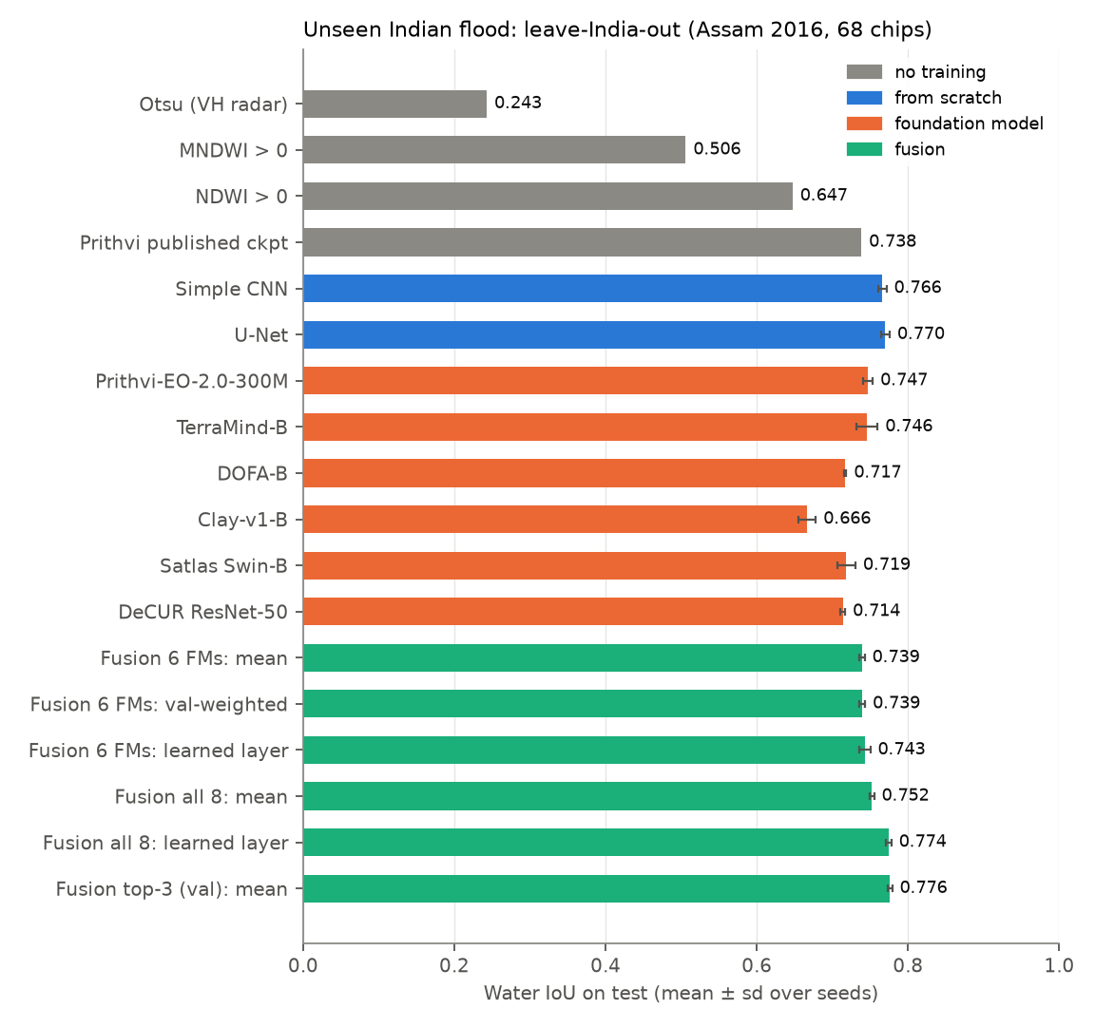
Test IoU on the unseen Indian flood (leave-India-out), mean ± sd over three seeds
- On the flood the models had never seen (Assam, Table A) the best single models are the two trained from scratch: U-Net 0.770 ± 0.006 and the simple CNN 0.766 ± 0.005. The best foundation models, Prithvi-EO-2.0 (0.747 ± 0.006) and TerraMind-B (0.746 ± 0.014), are about 0.02 IoU lower; Satlas, DOFA and DeCUR are at 0.714–0.719 and Clay at 0.666.
- On the official split (Table B) U-Net and CNN reach 0.840; the foundation models range from 0.802 (Clay) to 0.829 (Prithvi).
- Without training, Otsu thresholding of radar VH gets 0.23–0.24, NDWI 0.65–0.76. The published Prithvi flood checkpoint gets 0.738 on Assam, but it is not an unseen-event score: 40 of the 68 Assam chips were in its training set and 14 in its validation set.
- With ~250 labelled chips and all 15 bands available, pre-training on large unlabelled archives did not beat a well-trained U-Net for this task. Water has a strong spectral signature (NDWI alone reaches 0.65–0.76), and a 7.8 M-parameter network learns it from a few hundred chips. Training time: 3 min for U-Net, 6–15 min for the foundation models on one GPU.
The project scope listed CROMA, Galileo and TerraFM. None of them is in the backbone registry of TerraTorch 1.2.13 (1,467 backbones checked), the framework that gives all models here the same decoder, loss and data pipeline. Adding them would have meant a second, different training pipeline, so they were replaced by Clay, Satlas and SSL4EO-S12 DeCUR, which are in the same framework.

4.2 How much is lost on an unseen flood
Every model loses 0.07–0.14 IoU when the Indian event is not in training: U-Net 0.840 → 0.770, Prithvi 0.829 → 0.747, TerraMind 0.821 → 0.746, Clay 0.802 → 0.666. On the official split the India event itself is scored at 0.86–0.92 by the trained models (Table F) because the model has seen other chips of the same flood. For a new Indian flood, the leave-India-out numbers are the ones to expect, and this is the gap the mid-term result fell into.

4.3 Frozen encoder vs full fine-tuning
Table C. Frozen encoder vs full fine-tuning (test water IoU; frozen = seed 0, fine-tuned = mean of seeds).
Model | LIO frozen | LIO fine-tuned | Δ | Official frozen | Official fine-tuned | Δ | Trainable params frozen (M)
Prithvi-EO-2.0-300M | 0.723 | 0.747 | +0.024 | 0.808 | 0.829 | +0.021 | 20.3
TerraMind-B | 0.714 | 0.746 | +0.032 | 0.825 | 0.821 | -0.004 | 15.5
DOFA-B | 0.677 | 0.717 | +0.039 | 0.808 | 0.820 | +0.012 | 15.5
Clay-v1-B | 0.619 | 0.666 | +0.047 | 0.774 | 0.802 | +0.028 | 15.5
Satlas Swin-B | 0.670 | 0.719 | +0.048 | 0.786 | 0.819 | +0.032 | 5.1
DeCUR ResNet-50 | 0.711 | 0.714 | +0.003 | 0.828 | 0.827 | -0.002 | 9.0
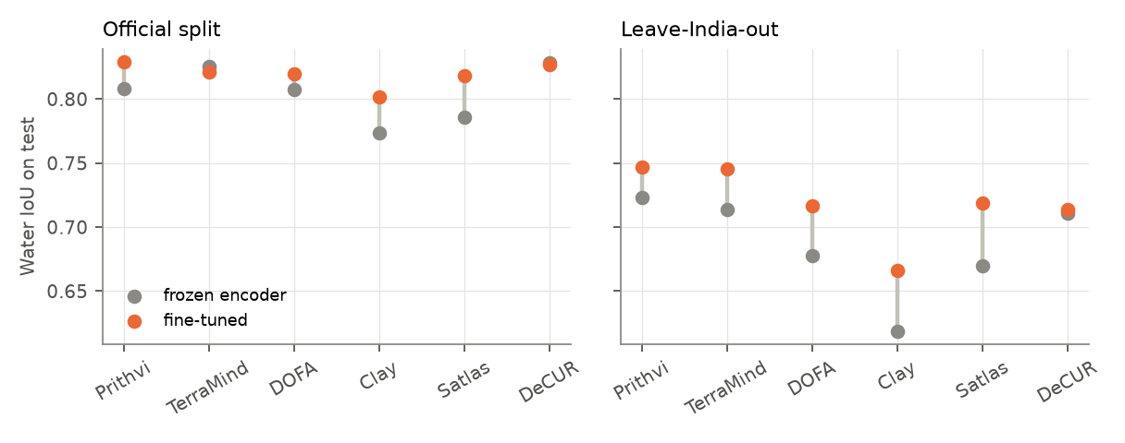
Frozen encoder vs full fine-tuning
On the unseen flood, fine-tuning helps every foundation model, by +0.003 (DeCUR) to +0.048 (Satlas). On the official split, frozen TerraMind (0.825) and frozen DeCUR (0.828) are as good as their fine-tuned versions, while only 5–20 M decoder parameters are trained. What pre-training gives for free is enough for events like those in training; moving to a new region needs the encoder to adapt.

4.4 Fusion (“fuse layer”)
Table E. Fusion of the six fine-tuned foundation models (test IoU, mean ± sd over seeds; best single model for reference).
Variant | LIO (Assam) | Official | Bolivia (LIO models)
Best single FM by validation (TerraMind-B / TerraMind-B) | 0.746 ± 0.014 | 0.821 ± 0.000 | 0.793 ± 0.019
Fusion 6 FMs: mean | 0.739 ± 0.004 | 0.837 ± 0.012 | 0.818 ± 0.004
Fusion 6 FMs: val-weighted | 0.739 ± 0.004 | 0.837 ± 0.012 | 0.818 ± 0.004
Fusion 6 FMs: learned layer | 0.743 ± 0.007 | 0.825 ± 0.007 | 0.805 ± 0.004
Fusion all 8: mean | 0.752 ± 0.003 | 0.840 ± 0.011 | 0.817 ± 0.004
Fusion all 8: learned layer | 0.774 ± 0.004 | 0.836 ± 0.001 | 0.804 ± 0.006
Fusion top-3 (val): mean | 0.776 ± 0.003 | 0.842 ± 0.001 | 0.801 ± 0.006
Learned fuse-layer weights (official_ens, seed 0): clay +0.02, decur +0.01, dofa +0.17, prithvi +0.25, satlas -0.04, terramind +0.23. Learned fuse-layer weights (official_ensall, seed 0): clay -0.13, cnn +0.15, decur +0.01, dofa +0.12, prithvi +0.14, satlas -0.06, terramind +0.19, unet +0.22. Learned fuse-layer weights (lio_ens, seed 0): clay -0.09, decur +0.16, dofa +0.09, prithvi +0.27, satlas -0.04, terramind +0.30. Learned fuse-layer weights (lio_ensall, seed 0): clay -0.16, cnn +0.28, decur +0.10, dofa +0.00, prithvi +0.22, satlas -0.10, terramind +0.23, unet +0.10.
- Fusing the six foundation models does not beat the best one on the unseen flood (0.739–0.743 vs 0.746–0.747), but helps on the official split (0.837 vs 0.829).
- Adding the two from-scratch models to the pool changes this: the learned fuse layer over all eight reaches 0.774 ± 0.004, and the mean of the three models with the best validation IoU (always U-Net and CNN, plus Prithvi in seed 0 and TerraMind in seeds 1 and 2) reaches 0.776 ± 0.003, the best leave-India-out result, with a small spread between seeds.
- The learned weights give Clay and Satlas zero or negative weight and TerraMind and Prithvi the largest weights among the foundation models; the fuse layer learns which members to ignore.

4.5 Radar, optical or both?
Table D. Which sensor is needed? Modality ablation on the unseen Indian flood (LIO test IoU, mean ± sd over seeds).
Model | Radar only (S1) | Optical only (S2) | Radar + optical
U-Net | 0.513 ± 0.007 | 0.763 ± 0.006 | 0.770 ± 0.006
TerraMind-B | 0.505 ± 0.021 | 0.755 ± 0.002 | 0.746 ± 0.014
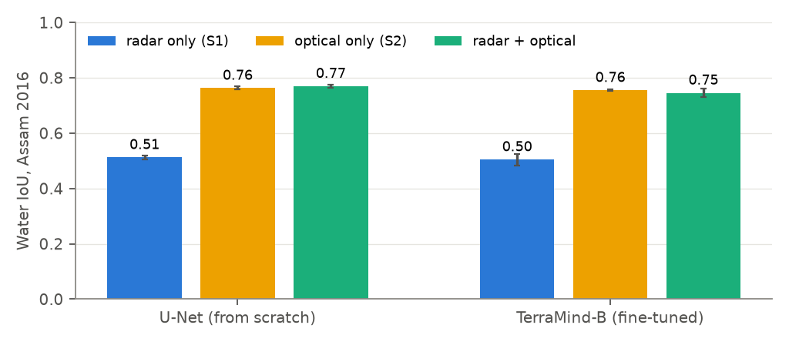
Modality ablation
Radar alone gives 0.51 on Assam, optical alone 0.76, both 0.75–0.77. This test favours optical by construction: Sen1Floods11 labels were drawn on the Sentinel-2 image, and pixels under cloud are labelled “unknown” and excluded from scoring. During a monsoon flood the optical image is mostly cloud (61–95 % over the Mahanadi delta on the flood dates, §6), so radar is the only sensor that sees the event. This answers the team’s dataset questions of 20 October: optical bands are the better input whenever the sky is clear, but the operational flood map has to work from radar; Section 6 therefore uses the radar-only models.

4.6 Threshold calibration, events, and flood vs permanent water
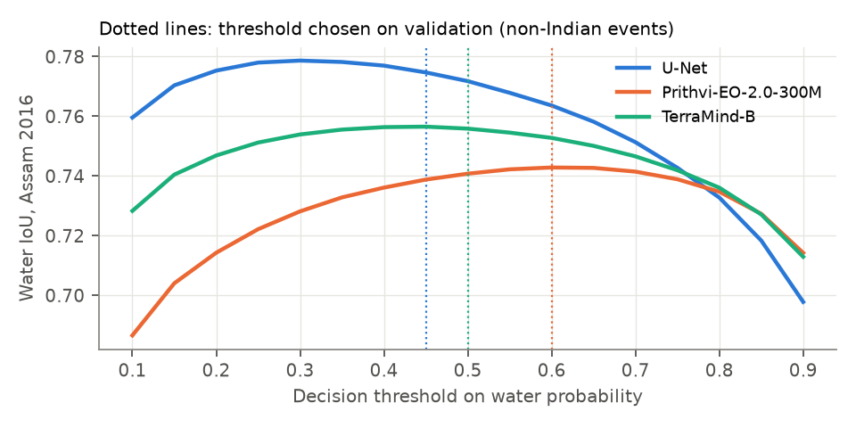
Threshold sweep on the unseen flood
- Choosing the decision threshold on validation (0.33–0.60 for the trained models) changes test IoU by less than 0.01; 0.5 is adequate for trained models. It matters for index methods (MNDWI 0.506 → 0.602) and for degraded input (the 20 m radar model of §6, where 0.3 is chosen).
- Water that is not JRC permanent water (closer to “flood”) scores about 0.05 lower than all water for every model (U-Net 0.722 vs 0.770 on Assam).
- By event (Table F): Mekong, Nigeria and Sri Lanka score above 0.9 and India 0.86–0.92; Ghana (0.53–0.66), Paraguay and Pakistan are hardest. Bolivia, never trained on, is 0.75–0.82.
Table F. Per-event test IoU, official split (mean over seeds; fine-tuned models and baselines).
Event | Otsu (VH radar) | MNDWI > 0 | NDWI > 0 | Prithvi published ckpt | Simple CNN | U-Net | Prithvi-EO-2.0-300M | TerraMind-B | DOFA-B | Clay-v1-B | Satlas Swin-B | DeCUR ResNet-50 | Fusion 6 FMs: mean | Fusion 6 FMs: val-weighted | Fusion 6 FMs: learned layer | Fusion all 8: mean | Fusion all 8: learned layer | Fusion top-3 (val): mean
Ghana | 0.11 | 0.67 | 0.51 | 0.57 | 0.57 | 0.58 | 0.56 | 0.55 | 0.57 | 0.62 | 0.58 | 0.66 | 0.59 | 0.59 | 0.53 | 0.59 | 0.53 | 0.57
India | 0.39 | 0.71 | 0.81 | 0.88 | 0.91 | 0.91 | 0.89 | 0.89 | 0.88 | 0.86 | 0.89 | 0.88 | 0.89 | 0.89 | 0.90 | 0.90 | 0.91 | 0.92
Mekong | 0.31 | 0.82 | 0.93 | 0.91 | 0.95 | 0.95 | 0.92 | 0.91 | 0.91 | 0.90 | 0.91 | 0.91 | 0.92 | 0.92 | 0.92 | 0.93 | 0.94 | 0.95
Nigeria | 0.30 | 0.91 | 0.89 | 0.92 | 0.94 | 0.94 | 0.93 | 0.93 | 0.92 | 0.92 | 0.93 | 0.92 | 0.93 | 0.93 | 0.93 | 0.93 | 0.94 | 0.94
Pakistan | 0.21 | 0.72 | 0.57 | 0.68 | 0.73 | 0.74 | 0.75 | 0.72 | 0.64 | 0.73 | 0.55 | 0.65 | 0.71 | 0.71 | 0.69 | 0.72 | 0.71 | 0.73
Paraguay | 0.17 | 0.37 | 0.53 | 0.75 | 0.63 | 0.63 | 0.66 | 0.61 | 0.72 | 0.60 | 0.76 | 0.74 | 0.73 | 0.73 | 0.65 | 0.68 | 0.63 | 0.63
Somalia | 0.16 | 0.57 | 0.71 | 0.77 | 0.85 | 0.85 | 0.80 | 0.80 | 0.78 | 0.71 | 0.79 | 0.78 | 0.80 | 0.80 | 0.80 | 0.82 | 0.83 | 0.85
Spain | 0.41 | 0.75 | 0.79 | 0.81 | 0.86 | 0.86 | 0.84 | 0.84 | 0.83 | 0.81 | 0.82 | 0.82 | 0.84 | 0.84 | 0.84 | 0.85 | 0.86 | 0.86
Sri-Lanka | 0.23 | 0.55 | 0.90 | 0.92 | 0.93 | 0.93 | 0.93 | 0.92 | 0.92 | 0.91 | 0.91 | 0.92 | 0.93 | 0.93 | 0.93 | 0.94 | 0.94 | 0.94
USA | 0.08 | 0.77 | 0.70 | 0.77 | 0.81 | 0.81 | 0.80 | 0.81 | 0.79 | 0.73 | 0.78 | 0.78 | 0.80 | 0.80 | 0.81 | 0.81 | 0.83 | 0.82
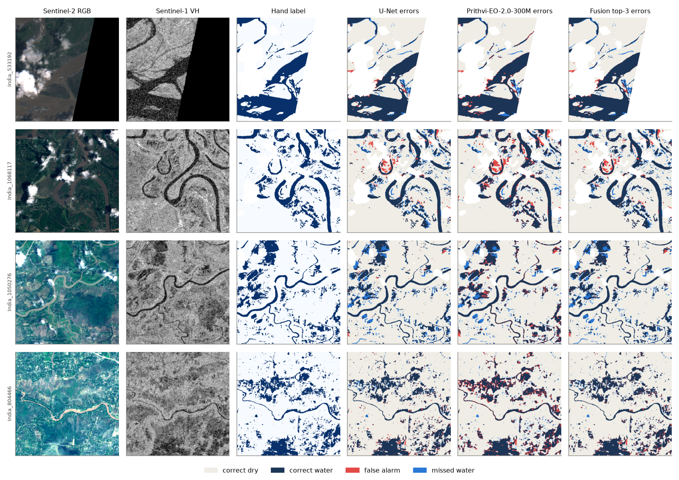
Error maps on Assam chips (U-Net, best foundation model, top-3 fusion)

4.7 Label efficiency
Table G. Label efficiency on the unseen Indian flood (LIO test IoU, mean ± sd over seeds; nested subsets of the 212 non-Indian training chips; epochs scaled so every run gets ~1,000 updates).
Model | 21 chips (10 %) | 53 chips (25 %) | 106 chips (50 %) | 212 chips (100 %)
Prithvi-EO-2.0-300M | 0.687 ± 0.015 | 0.711 ± 0.004 | 0.744 ± 0.009 | 0.747 ± 0.006
TerraMind-B | 0.694 ± 0.009 | 0.715 ± 0.002 | 0.741 ± 0.015 | 0.746 ± 0.014
U-Net | 0.736 ± 0.006 | 0.756 ± 0.015 | 0.773 ± 0.007 | 0.770 ± 0.006
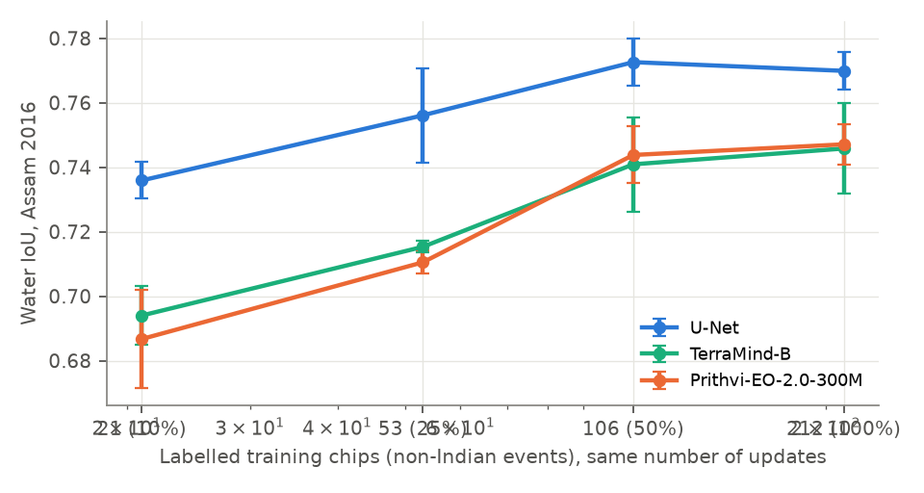
Label efficiency on the unseen flood
With only 21 training chips U-Net reaches 0.736, about what Prithvi and TerraMind reach with all 212 (0.747, 0.746). Every model is within 0.01 of its full-data score at 106 chips. In this task, foundation models are not more label-efficient than a U-Net.

4.8 What we take forward
- Model for a clear-sky Indian flood map: U-Net, or the top-3 fusion (U-Net + CNN + the best foundation model) when the extra cost is acceptable.
- Model for the monsoon (radar only): radar-only models score 0.65 on the official split and 0.51 on Assam. TerraMind-B is the only foundation model here that takes radar alone as a native input; averaged with a radar-only U-Net it gives 0.664 (official test), better than either alone (0.654, 0.649). This radar fusion is the production model of the Mahanadi atlas (§6).
- The foundation model’s value in this project is not a higher score on Sen1Floods11; it is that one pre-trained network takes optical, radar or both without redesign, which is what an operational system that loses its optical images under monsoon cloud needs.

5. Physics track: Saint-Venant equations and the PINN
All numbers below were produced on the lab server (CPU, TensorFlow 1.15 in a Python 3.7 environment built with micromamba; same package pins as the repository’s SETUP.sh). Logs are in pinn/results/logs/, figures in pinn/results/figures/. The case number for our team was never assigned, so we used case 3 (the reach the Phase-2 exercise is written against) for all from-scratch work, and validated all six cases from the published weights.

5.1 Environment check and reproduction of every case (published weights)
python phase4_validation/validate.py --case N
Case | Reach | ε_h (ours) | ε_h (paper) | RMSE | NSE | Deviation
1 | analytical, flat bed | 3.0750e-03 | 3.075e-03 | 0.001 m | 0.9999 | 0.0 %
2 | analytical, sloping bed | 3.6845e-02 | 3.685e-02 | 0.076 m | 0.9952 | 0.0 %
3 | HEC-RAS sub-reach | 6.6354e-03 | 6.635e-03 | 0.054 m | 0.9997 | 0.0 %
4 | same reach, 10× longer | 3.0928e-01 | 3.093e-01 | 1.771 m | 0.7837 | 0.0 %
5 | full reach | 9.8755e-02 | 9.876e-02 | 0.387 m | 0.9294 | 0.0 %
6 | full reach, 2 gauges (Fourier features) | 1.3962e-01 | 1.396e-01 | 0.674 m | 0.9080 | 0.0 %
Linear interpolation between gauges, for comparison: ε_h = 0.519 (case 5, NSE −0.95) and 0.369 (case 6, NSE 0.36). The PINN is 5× (case 5) and 2.6× (case 6) more accurate than interpolation on the same gauges.

5.2 Phase 1 — what the network is shown (case 3)
4,896 collocation points carry physics only. Initial profile, both boundaries and two interior gauges (cross-sections 16 and 32) carry data: the model sees 8.9 % of the reference field and has to reconstruct the other 91.1 % from the equations. Figure: case3_phase1_overview.png.

5.3 Phase 2 — residuals written from the equations (completed exercise)
pinn/p2b_residuals_completed.py implements the two residuals and checks them against the engine on every collocation point:
 | Case 3 (4,896 pts) | Case 5 (36,567 pts)
continuity: max | ours − engine
momentum: max | ours − engine
mean | continuity residual | of the trained model
mean | momentum residual | of the trained model
What the engine actually implements (the three “traps”):
- Continuity is non-conservative. The engine uses h_t + u·h_x = 0; the full form for a rectangular channel is h_t + u·h_x + h·u_x = 0. The two agree only if velocity is uniform along the reach (u_x ≈ 0). Evaluated on the trained solution, the dropped term |h·u_x| is on average 5 % of the retained terms on case 3 (mean 8.4e-3, max 2.9e-2) but 23 % on case 5 (median 11 %, max 0.13). The assumption is acceptable on the 1 km case-3 reach and clearly violated on the longer case-5 reach, where mass is not conserved by the loss the network minimises.
- Manning’s n is hard-coded to 0.015 inside fun_r_momentum (engine/SVE_module_dynamic_h.py:381); the value passed to the constructor is ignored.
- Friction uses |u|u, not u². With u² the friction term would accelerate reverse flow instead of opposing it. tf.pow(tf.square(R), 2/3) equals R^(4/3) for R > 0; squaring first keeps the power’s argument non-negative during training.
Loss balance at the trained optimum (case 3, p2c_loss_balance.py): continuity 3.0e-2, momentum 2.5e-2, upstream/downstream velocity boundary 3.1e-2, depth boundary 3.7e-3, initial depth 3.7e-3, gauge observations 6.7e-4 (u) and 5.5e-4 (h). The physics and velocity-boundary terms dominate; the gauges are fitted almost exactly because their adaptive weights grow to 128 (u) and 55 (h).

5.4 Phase 3 — retraining case 3 from scratch
python phase3_training/train.py --case 3 (8,000 Adam iterations, seed 1234), then validate.py --case 3 --trained:
Run | ε_h | RMSE | NSE | vs paper
Published weights | 6.635e-03 | 0.054 m | 0.9997 | —
Our retrain, Adam + L-BFGS-B | 6.457e-03 | 0.052 m | 0.9997 | 2.7 % better
Our retrain, --no-bfgs (Adam only) | 6.457e-03 | 0.052 m | 0.9997 | identical
Training took 334 s on CPU. Figure: case3_trained_profiles.png (PINN vs HEC-RAS reference at four times; the only visible miss is the drawdown near the upstream end at the last time step).

Finding: the L-BFGS-B stage does nothing on case 3
docs/05_known_issues.md (item 1) states that the L-BFGS-B refinement “is where most of the published accuracy comes from”. In our run it changed nothing:
- train_bfgs_safe (the course wrapper) evaluates the loss at 3.212 with the adaptive weights pinned at their final Adam values.
- The first trial step blows the momentum residual up to 3.07e+08; the line search returns to the start point and SciPy stops after 16 evaluations with the weights unchanged (log lines 2439–2454 of train_case3.log).
- Consequently the Adam-only run gives a bit-identical ε_h (6.4574e-03).
So, for case 3, all of the accuracy comes from the 8,000 Adam iterations, and our Adam-only model is already 2.7 % better than the published one. Whether L-BFGS-B helps on the longer cases (4–6) remains open; the first thing to check is the initial step size (the wrapper uses SciPy’s defaults).

5.5 Classical solver for comparison (sve_demo.py)
The MacCormack finite-difference solver from the mid-term report (Appendix A.1) was restored as a runnable script. It reproduces the mid-term numbers exactly: peak 400 → 313.7 m³/s at 8 km (+0.76 h) → 229.8 m³/s at 20 km (+2.25 h). Figure: sve_demo_hydrographs.png.

5.6 Verdict (Phase 4 question: would we recommend it to a river agency with two gauges?)
On a short reach with a calibrated HEC-RAS model already available (case 3), no: the PINN reproduces HEC-RAS to 5 cm RMSE, but it needs HEC-RAS boundary series to do so and adds 5–6 minutes of training per reach. Its real value appears on long reaches with sparse gauges (cases 5–6), where it beats linear interpolation by a factor of 2.6–5 in ε_h. Even there two caveats from this work apply: the continuity residual drops a term that is 11–23 % of the retained terms on case 5, and the published observations are noise-free (SNR 500 dB), so robustness to real gauge error is untested.

6. Mahanadi delta: flood atlas and the link to river flow

6.1 The atlas
The production model of §4.8 (mean of the radar-only TerraMind-B and U-Net, threshold 0.30) was run on 590 Sentinel-1 passes (133 in February–March, 457 in June–November, 2017–2026; tracks ascending 85: 184; descending 48: 211; descending 121: 195; platforms S1A 521, S1B 41, S1D 28). A pass is all slices of one satellite overpass; together they give a water map of the delta every 2–6 days in the monsoon. The river bed (main channels and sand bars, 178 km²) and each year’s dry-season water are “normal water”; only water outside them counts as flood. A 3 km band along each pass’s data edge is removed: a first version showed a diagonal stripe of false floods along one track’s swath edge.
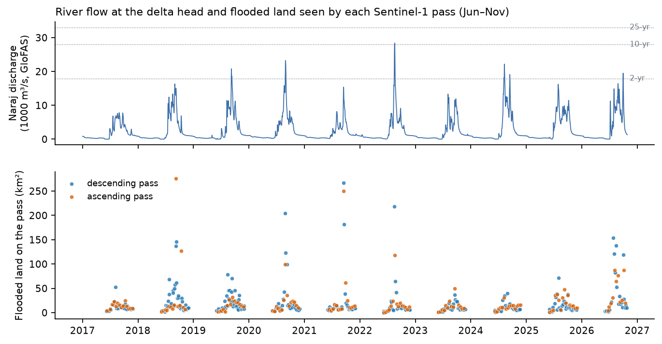
Flow at Naraj and flooded land on every pass
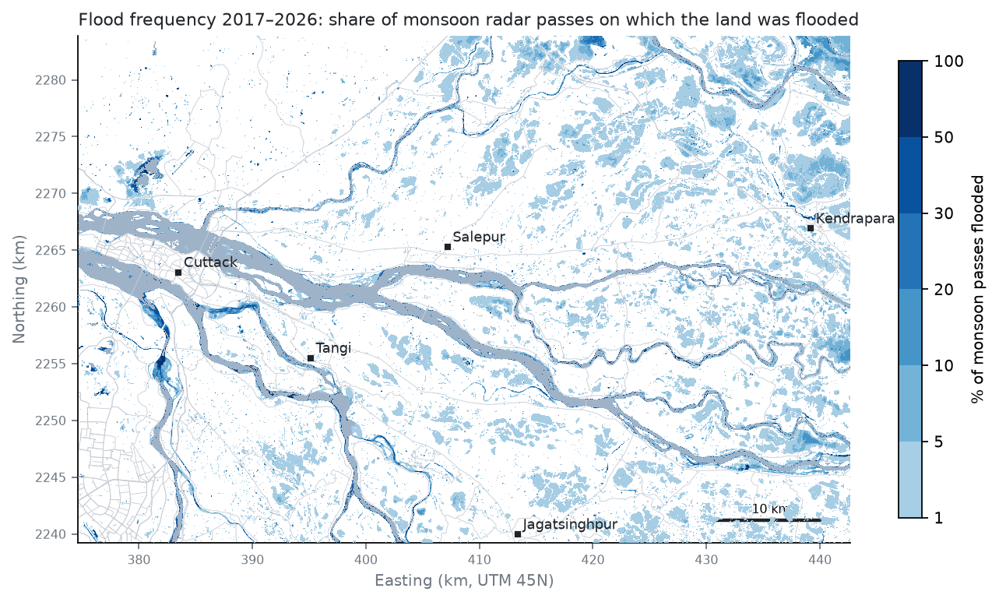
Flood frequency 2017–2026
- Land flooded on at least one pass: 905 km²; in at least 20 % of monsoon passes: 27 km².
- The largest flood seen on a near-complete pass was on 2018-09-08 (275 km² of flooded land).
- The flooded fraction of each pass follows the Naraj flow. Spearman ρ by predictor: same-day flow 0.75, previous-day flow 0.76, 3-day peak 0.76, 5-day peak 0.76, 7-day peak 0.75; the 5-day peak is used (floodplains drain slowly, so the map follows the recent peak more than the flow of the day).

6.2 Independent check with Sentinel-2
For 60 radar passes of June–November a Sentinel-2 image was taken within one day with enough clear sky (most of them at the end of the monsoon). On the pixels that are clear in the optical image, radar water agrees with optical water (MNDWI > 0) with IoU 0.49; taking the optical map as reference, the radar map has precision 0.60 and recall 0.73. For water outside the normal-water mask — the flood part — agreement drops to IoU 0.18 (precision 0.51, recall 0.22): the radar misses much of the shallow water that the optical image sees among crops and on water-logged fields, where the crop canopy dominates the radar echo. MNDWI has errors of its own (0.65 on the Sen1Floods11 official test, and wet soil reads as water), so neither map is truth; but the low flood-part recall says the radar atlas under-states shallow field flooding and is most reliable for open water. The field points (§8.3) are the next check.

6.3 Trigger discharge: which flow floods which land
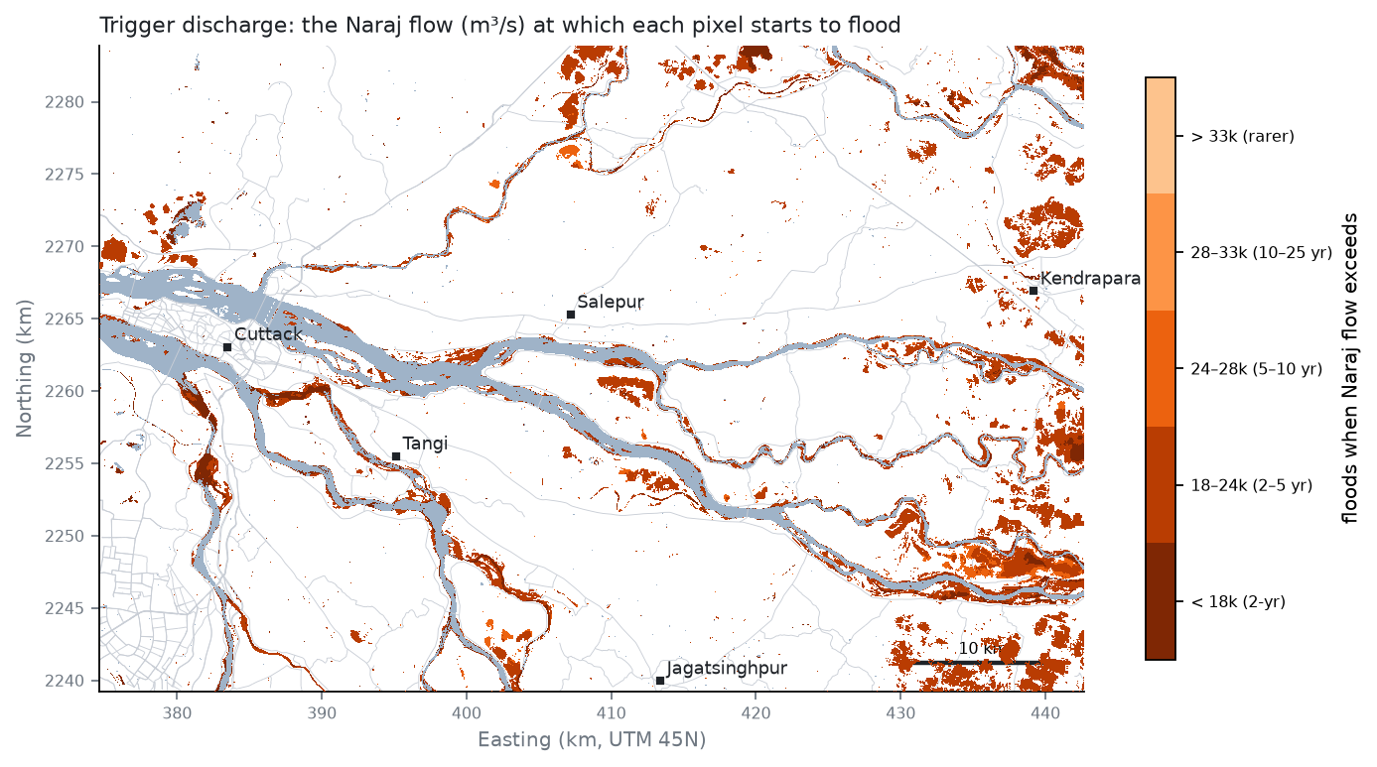
Trigger discharge
Every pixel gets the Naraj flow above which it is flooded (§3.5). The map reads directly as “at this forecast flow, this land goes under”. The river-driven score separates land that floods with the river from land that is wet in the monsoon whatever the river does: 662 km² has AUC ≥ 0.75, i.e. it floods mainly at high river flow, including fields far from the channels that flood when high river stages block their drainage.
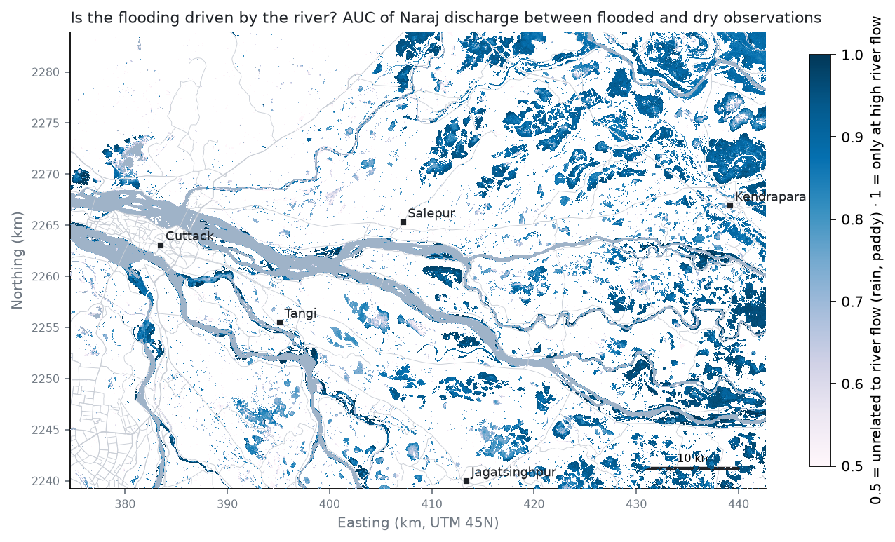
River-driven flooding

6.4 Does it predict years it has not seen?
For each year the trigger map was fitted on the other years and the year’s passes were predicted from their discharge alone.
Year | Passes | Largest flood on a pass (km²) | IoU, discharge model | IoU, climatology
2017 | 39 | 53 | 0.21 | 0.19
2018 | 57 | 276 | 0.17 | 0.11
2019 | 63 | 78 | 0.26 | 0.16
2020 | 46 | 204 | 0.20 | 0.10
2021 | 46 | 267 | 0.16 | 0.12
2022 | 43 | 218 | 0.32 | 0.13
2023 | 41 | 50 | 0.30 | 0.24
2024 | 43 | 39 | 0.26 | 0.24
2025 | 45 | 72 | 0.26 | 0.18
2026 | 34 | 154 | 0.20 | 0.09
Over all 457 monsoon passes the discharge model reaches IoU 0.23 (precision 0.57, recall 0.27) against 0.14 for climatology. On the 85 high-flow passes (Naraj ≥ 9,682 m³/s, the top 10 % of monsoon days), the ones that matter for warnings, it reaches 0.23 against 0.07 (recall 0.29 vs 0.07): climatology misses the extra land that only floods in big years. Predicted and observed flooded area correlate with r = 0.45.
Pixel IoU is a hard score here: the observed map is itself a radar map with ~0.65 IoU, and floodplain flooding is patchy. A warning is issued per village, so the same held-out test was scored per settlement (1,082 settlements; flagged when at least 10 % of the people are on flooded land). On high-flow passes the trigger map flagged 17% of the settlements that were actually flooded (POD), with 65% false alarms (FAR), CSI 0.13; climatology: POD 3%, FAR 23%, CSI 0.03. Over all monsoon passes: POD 18%, FAR 57%, CSI 0.14.
Where versus how much. Ranking the pixels of each held-out pass, the flood frequency of the other years reaches ROC AUC 0.93 (high flows 0.91), the trigger map 0.79 and the flow-and-rain analogs 0.80. Where the delta floods is very predictable from its past; how much of it floods on a given day is only partly predictable from river flow. Both layers are kept: the frequency map says where to prepare, the trigger map says at which flow to act.
The river is not the only driver. The largest flood extents in the record came with moderate Naraj flows: 8 September 2018 and 14–16 September 2021, when depressions brought 100–160 mm of rain a day over the delta (ERA5). A map driven by Naraj flow alone cannot predict those. The same held-out test was therefore repeated with analog maps: for each pass of the held-out year, the 7 training passes most similar in flow (or in flow and 7-day rain) are looked up, and land flooded on at least half of them is predicted flooded.
Method | IoU, all passes | IoU, high flow (≥ 9,682 m³/s) | IoU, heavy rain (≥ 135 mm in 7 days) | Settlements, high flow: POD / FAR | Settlements, heavy rain: POD / FAR
Trigger map (flow only) | 0.23 | 0.23 | 0.17 | 17% / 65% | 14% / 70%
Analogs on flow | 0.21 | 0.20 | 0.16 | 9% / 68% | 6% / 56%
Analogs on flow + local rain | 0.21 | 0.20 | 0.17 | 5% / 78% | 2% / 84%
Flood climatology | 0.14 | 0.07 | 0.05 | 3% / 23% | 2% / 17%
On the heavy-rain passes the best method is the flow-only trigger map (IoU 0.17), and adding rain to the analogs leaves their IoU about the same as the trigger map’s: at the scale of single passes rain is hard to use because the observed maps are noisy. The effect of rain is clear when the same method is asked about the same river flow. With the same analog method and the 5-year flow (23,940 m³/s), a dry week (20 mm of rain) gives 25 km² of flooded land with 5,021 people on it; a week with 171 mm (the monsoon 95th percentile) gives 105 km² and 11,802 people. For warnings this means the river forecast has to be read together with the rainfall forecast, which the ClimMaTech app already carries.
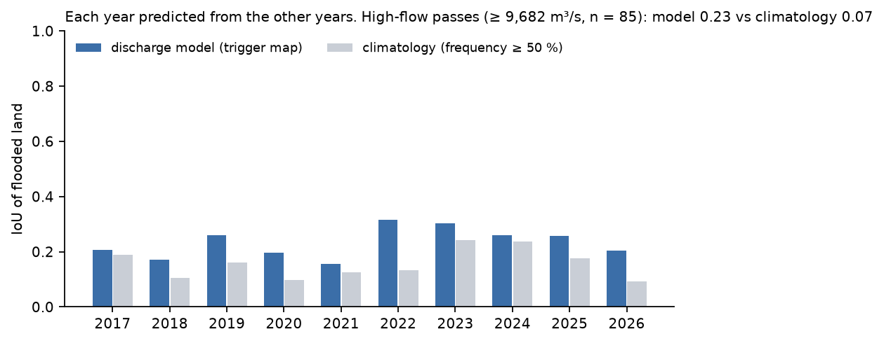
Leave-one-year-out test

6.5 Design floods and travel time
Gumbel fit to 42 GloFAS annual maxima at Naraj (1984–2025):
Return period (years) | Naraj flow (m³/s) | (lakh cusec) | Flooded land (km²)
2 | 17,897 | 6.3 | 38
5 | 23,940 | 8.5 | 203
10 | 27,941 | 9.9 | 216
25 | 32,997 | 11.7 | 216 (lower bound)
50 | 36,747 | 13.0 | 216 (lower bound)
100 | 40,470 | 14.3 | 216 (lower bound)
The largest flow in the radar record is 28,378 m³/s; above it the map cannot grow further and is a lower bound (25-yr, 50-yr, 100-yr).
Day-to-day changes of flow below Hirakud correlate best with those at Naraj 1 day later (r = 0.47), and those at Tikarpara on the same day (r = 0.93), in June–October 1984–2025 (daily data resolve only whole days). A release seen by a spillway sensor at Hirakud therefore gives about a day of lead time for the delta, on top of the hydrological forecast.

6.6 A learned flow + rain + history model
The trigger map uses the Naraj flow alone, and the analogs use rain only through similar past passes. A gradient-boosted classifier (scikit-learn HistGradientBoosting, mahanadi/learned_flood_model.py) was trained on pixels of every monsoon pass with the flow and 7-day rain of the pass, its month and radar track, and what the training years say about each pixel: trigger discharge, flood frequency overall, at high flows and in heavy rain, height above the nearest river bed and distance to it. Each year is predicted by a model fitted on the other years, a pixel is called flooded when its probability is at least 0.5 (the per-pixel error-minimising rule of the trigger fit), and the three methods are scored on the same held-out passes. Cells give IoU (precision / recall).
Held-out passes | Learned model | Trigger map | Flood climatology
All monsoon passes (457) | 0.24 (0.51 / 0.32) | 0.23 (0.57 / 0.27) | 0.14 (0.64 / 0.15)
High flow (85) | 0.24 (0.43 / 0.35) | 0.23 (0.51 / 0.29) | 0.07 (0.82 / 0.07)
Heavy rain (46) | 0.22 (0.40 / 0.33) | 0.17 (0.49 / 0.21) | 0.05 (0.75 / 0.05)
Settlements, high flow: POD / FAR | 21% / 71% | 17% / 65% | 3% / 23%
Settlements, heavy rain: POD / FAR | 18% / 76% | 14% / 70% | 2% / 17%
Ranking AUC, all / high flow | 0.95 / 0.93 | 0.79 / 0.76 | 0.93 / 0.91
The learned model is better than the trigger map on all passes and on heavy-rain passes. At village level, at high flows, it catches more flooded villages than the trigger map (21% against 17%) and raises more false alarms (71% against 65%); the critical success index, which weighs both, is 0.14 against 0.13. It ranks flood-prone land best of the three (ROC AUC 0.95). The physical direction of each input is imposed (more flow or rain, a flow further above the trigger or a pixel that flooded more often never lowers the probability): a first run without these constraints scored 0.233 IoU but gave less flooded land for heavy than for typical rain at the 25-year flow (108 against 121 km²), which a warning map must never do. The inputs it leans on most (drop in held-out ranking AUC when each is shuffled): flood frequency 0.163; Naraj flow 0.030; 7-day rain 0.022; month 0.008; elevation 0.008. Fitted on all years, it floods 44 km² at the 5-year flow in a dry week, 64 km² with typical rain and 172 km² with heavy rain (August, averaged over the three radar tracks; typical rain = median 7-day rain of the monsoon passes (58 mm); heavy rain = monsoon 95th percentile (171 mm)), the same roughly four-fold effect of rain as the analog maps of §6.4. For a warning system this is the model that takes both of ClimMaTech’s inputs, the river forecast and a rain-gauge or forecast rain total, and returns one map.

6.7 Limits
- Discharge is modelled (GloFAS), not gauged. CWC/WRD daily flows at Naraj are the first thing to request (§8.1); with them the trigger map is refitted in minutes.
- Radar misses water under dense vegetation and in towns, and sees smooth surfaces as water. The model scores 0.65 on the official test with radar only; the atlas inherits that.
- Short floods between passes (2–12 days apart) are missed; Sentinel-1C/D (2025–26) shorten the gap.
- Paddy: transplanted paddy holds water in July–August. Land whose wetness does not follow the river (low river-driven score) should not trigger river-flood warnings.
- Flows beyond the record (rarer than the largest flood seen since 2017) are lower bounds.

7. Seven specializations, one flood
The department’s seven specializations each answer one question about the same flood scenarios: the design floods of §6.5, land flooded in at least 10 % of monsoon passes, and the largest flood seen. This chapter gives, for each one, why it matters for a flood warning, what was done and what was found, briefly; formulas, parameters and full tables are in Appendix C. Remote sensing is chapters 4 and 6; water resources is chapter 6 and §7.8, which adds the watershed above the delta. The 10- to 100-year scenarios are identical because the largest flow in the radar record (about 28,400 m³/s, roughly a 10-year flood) bounds what the atlas can map, so they are lower bounds.
Specialization | Question | Method | Headline result (25-year flood unless stated) | Field check (§8) | Owner
Remote sensing | Which model maps Indian floods through cloud? | Benchmark of 6 FMs vs CNN/U-Net; Sentinel-1 atlas; Sentinel-2 check | U-Net 0.770, best FM 0.747 (unseen flood); 590 passes mapped | 40 random ground-truth points | Vineet, Prakhar
Water resources | Which flow floods which land? | GloFAS + ERA5, trigger discharge, held-out years, Gumbel | High-flow IoU 0.23 vs 0.07 climatology; 25-yr flow 32,997 m³/s | Discharge, Manning’s n | Nikhil
Transportation systems | Who loses the road to a hospital or shelter? | OSM road graph, flooded edges cut, Dijkstra | 36,941 people cut off from any hospital; 12,023 extra person-hours of travel a day | Road closures at critical links | Himanshu
Structural | Where do walls crack; how deep must piers go? | DEM flood depth, wall moment check, IRC:78 Lacey scour | 3,626 people where depth ≥ 1 m; pier scour 7–24 m below HFL (100-yr, a quarter of the flow) | Deck clearance, HFL marks, foundation levels | Himanshu
Geotechnical | Which banks fail; which dry houses sit on soaked ground? | Bank screening; 200 m saturation advisory; bearing / settlement checks | 415,549 people in the advisory zone; bearing loss 55 % when soaked | Soil samples, well levels, slopes | Prabhat
Ocean | What do Bay of Bengal storms add? | IBTrACS tracks vs atlas; flood drivers | 37 systems within 300 km since 2016; 11 of the 20 largest floods followed one | Interviews on surge and tidal drainage | Nikhil
Construction technology & management | When to build, what it costs, in what order | Flood/storm climatology, earthwork take-off, BoQ, schedule | Work window December–April; 17,442 m³ to raise 8 critical links, 2 more need a bridge or vented causeway | Site sheets for sensors/sirens | Prabhat

7.1 Exposure: who and what is on flooded land
Why it matters. A warning has to say who is at risk, not how many square kilometres flood. What we did. Each scenario was overlaid with population (GHSL), settlements, farmland (WorldCover), roads, railways, bridges, hospitals and schools (OpenStreetMap). What we found. The 25-year flood covers 216 km² of land with 25,163 people on it, 24 settlements with at least 10 % of their people on flooded land, 164 km² of cropland and 32 km of road. Most flooded land is farmland; the people exposed live in villages at its edges, which is why the viewer and the bulletin list settlements, not totals.

7.2 Transportation systems
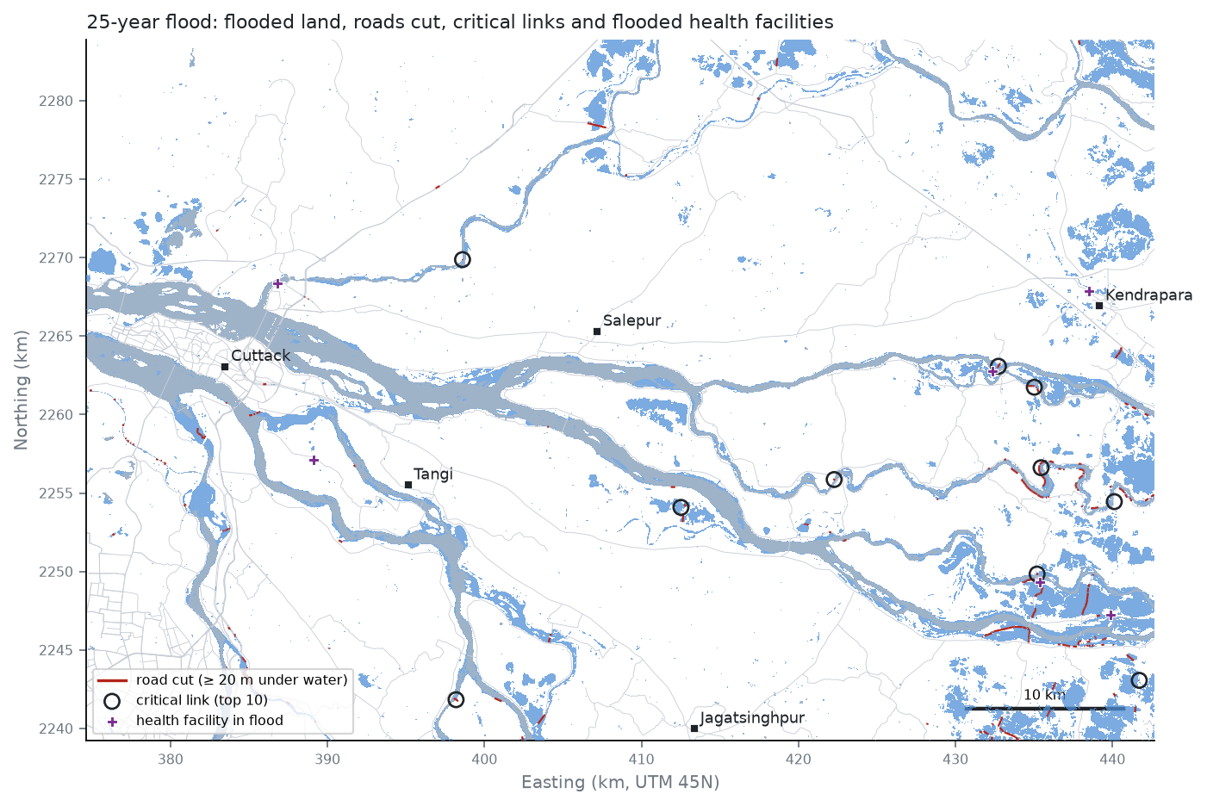
25-year flood: roads cut and critical links
Why it matters. A flooded road is a lost hospital trip, a blocked evacuation and a long detour to market. What we did. The OpenStreetMap road network became a graph; flooded sections were cut and shortest paths to hospitals, towns and dry schools compared with dry weather. What we found. In the 25-year flood 36,941 people in 32 settlements lose road access to any hospital, 24,345 more reach one only by a detour, and everyday trips grow by about 12,023 person-hours a day. Ten critical links carry most of the cut-off routes (C.2). At the site: road closures at those links.

7.3 Structural
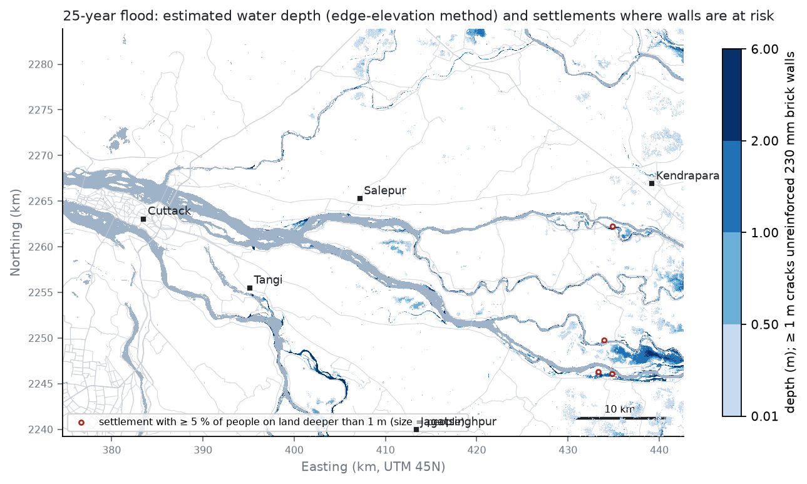
Estimated flood depth
Why it matters. Standing water pushes over brick walls, and scour undermines bridge piers. What we did. Flood depth from the ground elevation at the flood edge; a bending check of unreinforced brick walls; IRC:78 scour at 11 major bridges. What we found. A 230 mm brick wall cracks at about 0.8–1.0 m of water, and 3,626 people live where the 25-year flood is a metre deep or more. Pier scour reaches 7–24 m below the high flood level if a branch carries a quarter of the 100-year flow; how the flow splits between branches is the missing input. At the site: flood marks, deck clearance and foundation levels.

7.4 Geotechnical: river banks
Why it matters. Embankment breaches cause the worst local floods. What we did. 663 one-kilometre bank cells were ranked by how often water stands behind the bank, in how many years, how erodible the soil is and how many people live nearby. What we found. Twenty inspection sites at least 3 km apart (map and list in C.4); SoilGrids at 250 m cannot tell one bank from another, so the field samples and lab tests decide. At the site: bank inspection, slopes and soil samples.

7.5 Geotechnical: ground under houses that stay dry
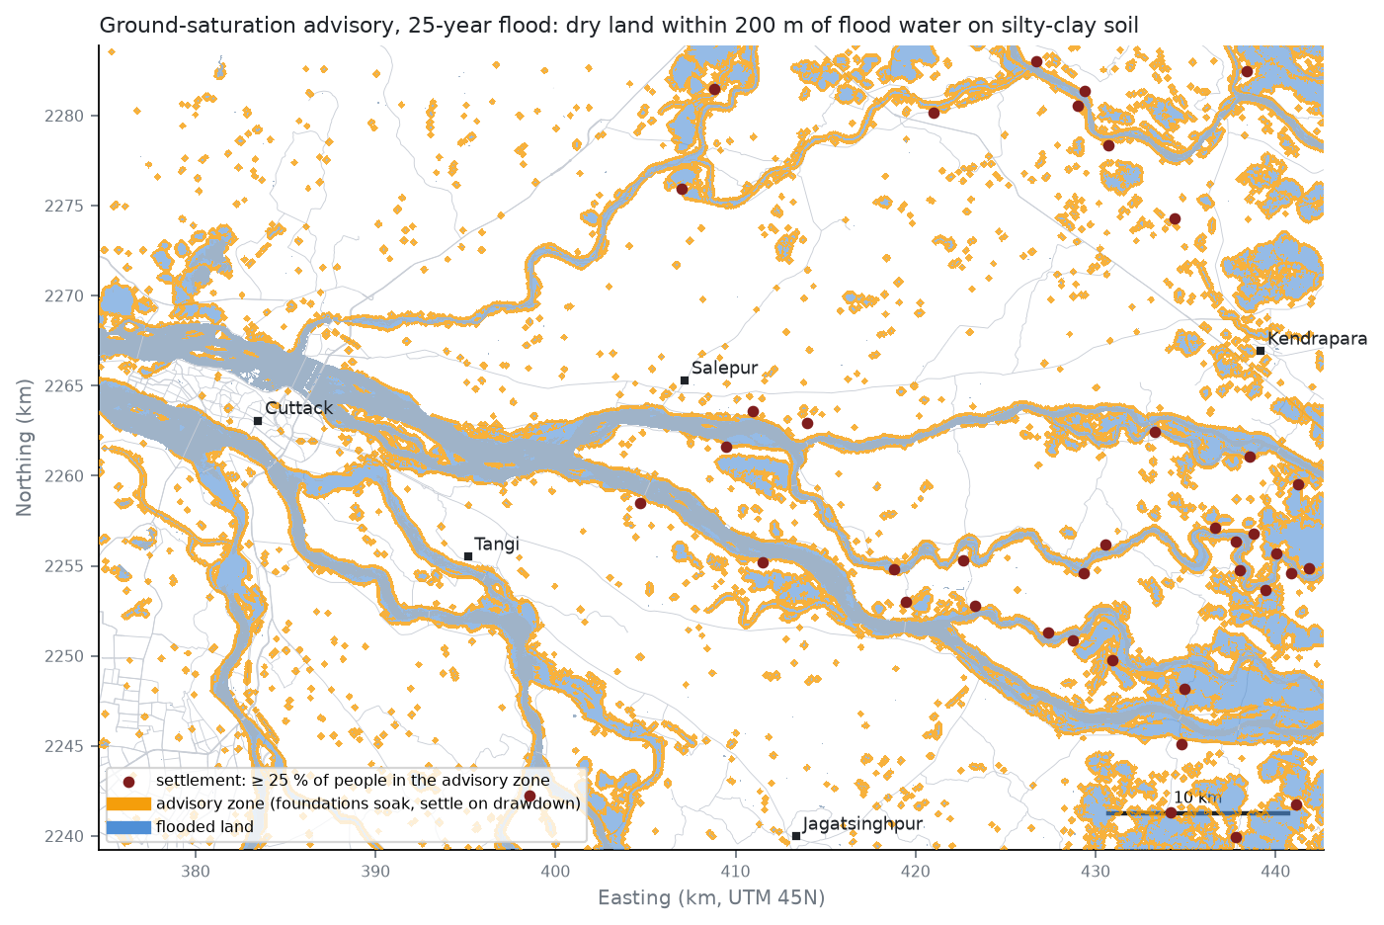
Ground-saturation advisory
Why it matters. Floodwater raises the groundwater under dry houses nearby: foundations weaken while it is high and settle when it drops. What we did. An advisory zone of dry land within 200 m of flood water on fine-grained soil, with textbook bearing-capacity and settlement checks. What we found. 415,549 people (310 settlements) live in the zone in the 25-year flood; soaking cuts the bearing capacity of a strip footing on silty sand by about 55 %, and a 2 m drop of the water table settles soft clay by 20 to 39 mm. At the site: water levels in village wells at 0–500 m from the flood edge.

7.6 Ocean
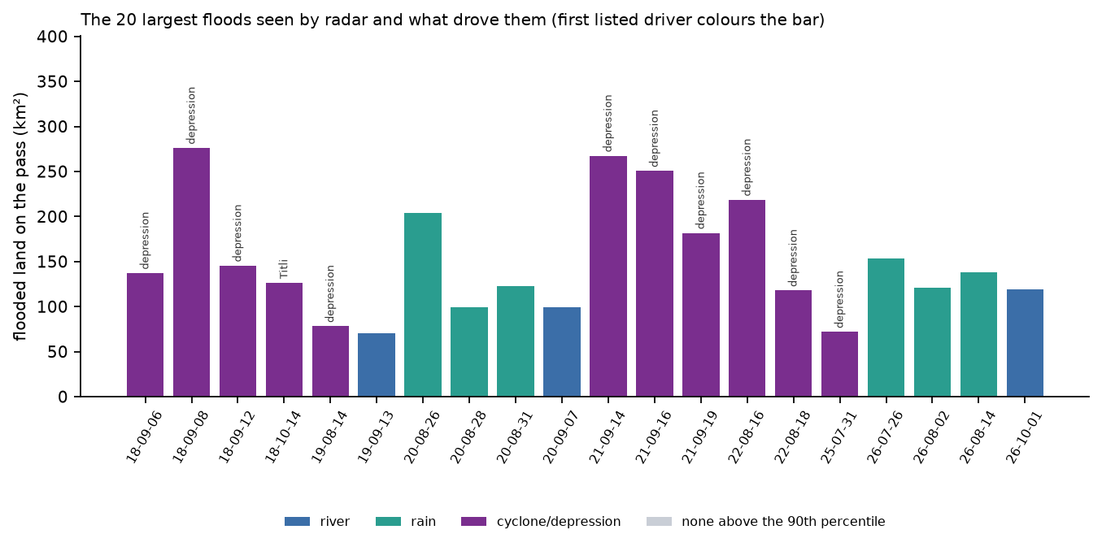
Flood drivers
Why it matters. Bay of Bengal cyclones and depressions bring the heaviest rain, and surge and tide hold back the drainage of the lower delta. What we did. IBTrACS storm tracks were matched to the radar floods. What we found. 37 systems passed within 300 km since 2016; of the 20 largest floods, 11 followed one, 14 came with heavy rain and 18 with a high river. At the site: interviews on surge and tide-locked drainage.

7.7 Construction technology and management
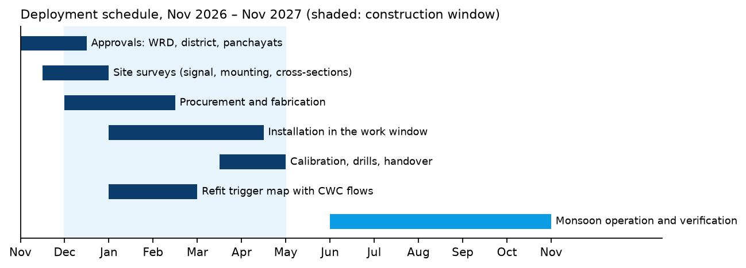
Deployment schedule
Why it matters. Protection and sensors must be built outside the flood season, in the right order and within a budget. What we did. Monthly flood and storm climatology, an earthwork take-off for raising the critical links, deployment quantities and a schedule. What we found. The work window is December–April. Raising 8 critical links takes about 17,442 m³ of earthwork (about ₹0.61 crore at an assumed ₹350/m³); 2 more would need raises above 3 m, that is a bridge or a vented causeway. Installing 40 sirens and 6 river gauges takes about 78 crew-days. At the site: access, mounting and signal at the proposed sites.

7.8 Water resources and the watershed
Why it matters. The delta’s floods are set upstream, by releases from Hirakud dam and by rain on the uncontrolled tributaries below it, so a warning for the delta is a warning about the whole watershed. What we did. GloFAS flows below Hirakud, at Tikarpara and at Naraj (1984–2025) were compared at the annual flood peak and over the monsoon (C.8), next to the travel times and design floods of §6.5. What we found. Hirakud controls about 59 % of the basin (83,400 of about 141,600 km²) and passes 60% of the July–September flow at Naraj, but only a median 48% of the annual flood peak (29 years): the other half comes from the roughly 58,000 km² below the dam, within about a day. A delta warning therefore needs both the dam’s release plan and gauges on the tributaries below it, and watershed measures in that lower catchment (land cover, soil conservation, small storages) act on the frequent floods more than on the rare largest ones. At the site: discharge and Manning’s n at a road bridge; the WRD’s account of gate operations.

8. Field visit: what we measure, whom we ask, and what it changes
The 14 October review was explicit: the committee will ask what we did at the site, what we took from it and how it changed the work. The visit is therefore designed around the gaps the models cannot close by themselves. The full protocols, equipment and safety rules are in fieldkit/FIELD_VISIT_KIT.md; the data sheets are the CSV files in fieldkit/templates/; every sheet has an analysis script in fieldkit/analysis/, tested on made-up example sheets (fieldkit/examples/, marked EXAMPLE, never reported as results).
Status (29 Oct 2026): visit being arranged with Prof. Basudev Biswal (Mahanadi basin project) and ClimMaTech. Sections 8.3–8.7 are filled in from the field sheets after the visit; until then they state the method only.

8.1 Where and with whom
Planned area: the Mahanadi delta between Naraj (delta head, CWC gauge, Naraj and Mundali barrages) and Kendrapara. Hosts and interviews: Odisha Water Resources Department (Mahanadi divisions, Cuttack), CWC Mahanadi division, the district emergency office, ClimMaTech, and residents at the check points. Data requested before the visit: daily discharge at Naraj/Mundali 2017–2025, embankment inventory and breach history, villages evacuated in 2020 and 2022, NDEM flood layers for August 2020 and 2022.

8.2 Check points carried to the field
fieldkit/checkpoints/checkpoints.gpx (phone GPS) and .kml (Google Earth), generated from the atlas and impact results by mahanadi/make_checkpoints.py:
Code | Number | What | Chosen how
GT | 40 | Ground-truth points | Random, 10 in each atlas class (never / < 10 % / 10–30 % / ≥ 30 % of passes flooded), within 150 m of a road and 1 km of a settlement, ≥ 2 km apart
SR | 15 | Siren sites | Top of the greedy coverage list (§9)
RS | per river | River-sensor bridges | One per main distributary (§9)
GB | 12 | Bank inspection and soil sampling | Top of the geotechnical screening (§7.4)
RL | 10 | Critical road links | Flooded links carrying most people’s hospital route (§7.2)
HF | ≤ 10 | Health facilities flooded in the 25-year flood | §7.1
WL | 8 | Well water levels | Settlements in the ground-saturation advisory list (§7.5)
Random ground-truth points matter: checking the map only where it is easy to reach, or only where it shows water, would overstate its accuracy.

8.3 Atlas accuracy at the ground-truth points (to be filled after the visit)
Method: fieldkit/analysis/field_validate_map.py. Each (point, year) pair with a local answer is one test: hit, miss, false alarm or correct negative, with a 60 m window for GPS error. Report POD, FAR and CSI, the flood-mark heights, and the cases where people and the atlas disagree, with the likely reason (short floods between radar passes, flooded paddy, water under tree cover, memory of the wrong year).
What it changes: the accuracy statement that goes with the map to ClimMaTech; if misses cluster in short floods, the atlas needs the denser 6-day revisit of Sentinel-1C/D; if false alarms cluster on paddy, the river-driven mask (§6.4) must be applied before warnings. The flood-mark heights are compared with the DEM-based depth (§7.3): the wall screening and the road-raising earthwork (§7.7) scale with that depth.

8.4 Discharge and roughness at a bridge (to be filled after the visit)
Method: cross-section from the bridge and float timings, velocity-area method (ISO 748 mid-section, surface-to-mean factor 0.85 with 0.80–0.90 as the range), water-surface slope over 200–500 m; discharge_velocity_area.py and manning_cowan.py.
What it changes: (1) measured flow vs GloFAS for that day, a first check of the modelled discharge that drives §6; (2) Manning’s n from slope and discharge and from Cowan’s method vs the n = 0.015 that the PINN assumes (§5): the Saint-Venant case is re-run with the measured n; (3) if a ClimMaTech or CWC radar gauge is on the bridge, our float discharge against its level and surface-velocity reading.

8.5 Bridges and roads (to be filled after the visit)
Method: deck-to-water, deck thickness, high-flood-level marks, scour and debris, closure history; bridge_clearance.py checks the clearance above HFL against IRC:5 (1.5 m for Q > 3,000 m³/s). At the critical links: was the road closed in 2020/2022, for how long, which detour was used.
What it changes: confirmed closures validate the network model; a road the model calls safe but locals report cut (or the reverse) re-ranks the critical links of §7.2; bridges with insufficient clearance or scour are added to the structural list.

8.6 River banks and soils (to be filled after the visit)
Method: bank geometry, seepage and boils, cracks, burrows, breach history; two samples per GB site; in the IITB geotechnical laboratory wet sieving (IS 2720 Part 4) and liquid/plastic limits (IS 2720 Part 5); soil_gradation.py gives the IS 1498 and USCS class, Cu, Cc, PI, the Kenney–Lau internal-stability check and a piping-susceptibility flag.
What it changes: measured classes replace the SoilGrids texture in the bank-screening ranking (§7.4); cells with non-plastic silty sand and recurrent water behind the bank move to the top of the inspection list.

8.7 Sensor and siren sites, and the interviews (to be filled after the visit)
Method: structure, mounting height, view of the channel, mobile signal (dBm), sun hours, access in a flood, security, permissions; interview notes in interviews.csv.
What it changes: sites without signal or without flood-time access are dropped from the deployment plan (§9); the engineers’ rule of thumb for “which flow at Naraj floods which villages” is compared with the trigger- discharge map (§6.3); the constraints heard in the interviews are written into the problem statement (§1.1).

8.8 Groundwater beside the flood (to be filled after the visit)
Method: water levels in 8–12 village wells at roughly 0–50, 50–100, 100–200 and 200–500 m from land that floods, with the residents’ account of how high the wells rose in the last flood and whether houses cracked or settled after it (protocol H, templates/well_levels.csv).
What it changes: the 200 m distance of the ground-saturation advisory (§7.5) is replaced by the distance at which the wells stop responding to the flood; reported cracking after floods tests the drawdown-settlement explanation.

9. Implementation for ClimMaTech: what a deployment would use

9.1 Where it fits
ClimMaTech’s system observes (radar gauges), predicts (level and flow 30 min to 48 h ahead) and warns (sirens, Aagah app, control centre). This project adds the step between “predict” and “warn”: forecast flow at Naraj → flooded land → settlements, roads and facilities affected, from the trigger-discharge map of §6.3 and the impact layers of §7.
ClimMaTech / CWC forecast of Naraj flow ──► forecast_to_impact.py ──► flood map (GeoTIFF)
(m³/s or lakh cusec, lead time) trigger map + impacts settlements to warn (GeoJSON) ──► Rakshak Control Centre, Aagah
roads under water, bulletin text ──► district / OSDMA
Sentinel-1 pass (every 2-6 days) ──► atlas_infer.py ──► observed flood map ──► refit trigger map each season

9.2 Forecast-to-bulletin tool
python mahanadi/forecast_to_impact.py --q <flow> (or --lakh-cusec, and --rain <mm> for the flow-and-rain analogs) runs in seconds. Output for the 5-year flow (23,940 m³/s; the 25-year and rain bulletins are in results/impact/bulletins/):
MAHANADI DELTA - EXPECTED FLOODING FOR A NARAJ FLOW OF 23,940 m3/s (8.5 lakh cusec), lead time 24 h
(flow = highest daily flow over 5 days at Naraj, the measure the atlas is fitted on; method: trigger-discharge map, river flow only)
Expected flooded land: 203 km2
People living on that land: 22,545
Settlements with at least 10 % of people on flooded land: 20
- near Patkura (9.7 km): about 321 people (46% of 704) at 20.3133 N, 86.3615 E
- near Biridi (1.4 km): about 309 people (54% of 574) at 20.3319 N, 86.0429 E
- near Bhattasagar Square (7.0 km): about 234 people (15% of 1,613) at 20.6301 N, 86.1248 E
- near Patkura (2.7 km): about 152 people (24% of 647) at 20.4002 N, 86.3823 E
- near Patkura (1.5 km): about 78 people (28% of 281) at 20.3855 N, 86.3917 E
- near Dhuria (8.6 km): about 76 people (14% of 529) at 20.4610 N, 86.3444 E
- near Choudwar (4.0 km): about 75 people (11% of 694) at 20.5588 N, 85.8918 E
- near Patkura (14.6 km): about 71 people (16% of 440) at 20.2606 N, 86.4338 E
- near Patkura (9.3 km): about 65 people (25% of 269) at 20.3113 N, 86.3760 E
- near Patkura (10.8 km): about 62 people (25% of 247) at 20.3116 N, 86.3447 E
- near Patkura (9.1 km): about 59 people (23% of 253) at 20.3116 N, 86.4309 E
- near Nemalo (1.2 km): about 58 people (14% of 414) at 20.4409 N, 86.1674 E
- near Gobindpur (2.2 km): about 48 people (15% of 326) at 20.3460 N, 86.0320 E
- near Patkura (14.9 km): about 47 people (13% of 352) at 20.2562 N, 86.4195 E
- near Bhattasagar Square (5.9 km): about 44 people (11% of 417) at 20.6256 N, 86.1147 E
Main roads under water: 10.9 km
Source: Sentinel-1 flood atlas 2017-2026 + GloFAS discharge (IIT Bombay IDP prototype). Not an official warning.
The interactive viewer (dashboard/index.html, one file, works offline) shows each design flood with flooded land, roads cut, the settlements list (click to zoom), siren and sensor sites and the bank-inspection cells.

9.3 Siren sites
Greedy maximal coverage of the 27,371 people living on land flooded in the 25-year flood or in at least 10 % of monsoon passes. With 40 sirens the share covered is 34%, 49% and 62% for an audible range of 1.0, 1.5 and 2.0 km. At 1.5 km: 10 sirens cover 26%, 20 cover 37%. Exposed people are spread thinly over many small settlements, so the first sirens give most of the benefit; the rest is better reached by phone alerts (Aagah) than by more sirens.
Rank | Settlement | Location | New people covered | Cumulative share
1 | Fakirabad | 20.5029 N, 86.4186 E | 1,561 | 6%
2 | near Patkura (8.5 km) | 20.3190 N, 86.3756 E | 1,067 | 10%
3 | near Patkura (1.5 km) | 20.3872 N, 86.4195 E | 696 | 12%
4 | near Gobindpur (1.1 km) | 20.3312 N, 86.0318 E | 602 | 14%
5 | near Balachandrapur (1.4 km) | 20.6305 N, 86.2469 E | 565 | 16%
6 | near Patkura (2.4 km) | 20.4047 N, 86.3886 E | 565 | 18%
7 | near Bhattasagar Square (7.0 km) | 20.6301 N, 86.1248 E | 522 | 20%
8 | near Fakirabad (6.7 km) | 20.4514 N, 86.3849 E | 486 | 22%
9 | near Balachandrapur (3.8 km) | 20.6377 N, 86.2729 E | 481 | 24%
10 | near Patkura (5.9 km) | 20.3416 N, 86.3819 E | 469 | 26%
11 | near Patkura (8.6 km) | 20.3448 N, 86.3385 E | 393 | 27%
12 | Badambadi | 20.4658 N, 85.8797 E | 378 | 28%
13 | near Patkura (2.2 km) | 20.4084 N, 86.4129 E | 366 | 30%
14 | near Patkura (3.9 km) | 20.3910 N, 86.4426 E | 364 | 31%
15 | near Patkura (14.9 km) | 20.2598 N, 86.4417 E | 279 | 32%

9.4 River-sensor bridges
One non-contact radar gauge (level and surface velocity) at the head of each main distributary measures how the flood splits between the branches, which the Naraj forecast alone cannot tell:
River | Bridge | Road class | Length (m) | km from Naraj | Approaches dry in 25-yr flood | Location
Devi River | Netaji Subhash Chandra Bose Setu | primary | 2823 | 8 | yes | 20.4546 N, 85.8481 E
Kathajodi | NH16 | trunk | 869 | 13 | yes | 20.4405 N, 85.8901 E
Birupa | NH16;NH55 | trunk | 543 | 17 | yes | 20.5133 N, 85.9320 E
Luna | (unnamed) | unclassified | 776 | 31 | no | 20.4650 N, 86.0743 E
Mahanadi | (unnamed) | unclassified | 458 | 52 | yes | 20.3668 N, 86.2642 E
Biropa | (unnamed) | unclassified | 424 | 60 | no | 20.6261 N, 86.3224 E
Pravaah needs a surveyed cross-section and a surface-to-mean velocity factor to give discharge (ClimMaTech documentation); the field protocol B–C measures exactly these at one bridge (§8.4).

9.5 Rolling it out
- Season 0 (now): hand the trigger map, bulletin tool and viewer to ClimMaTech; refit with CWC/WRD observed flows.
- Before the next monsoon: field-verified siren and sensor sites (§8.7); first sensors at the heads of the Mahanadi and Kathajodi branches.
- During the monsoon: map every new Sentinel-1 pass (6 s per pass on the lab GPU, ~2 min to download) and compare with the bulletin of that day; add the season to the atlas.
- Each year: refit the trigger map, update design floods, re-rank links and banks.

9.6 Gaps in the partner’s services and what this project adds
All 50 public pages of climmatech.com were downloaded on 29 October 2026; the product, solution, platform, fact-sheet and case-study pages were read in full and the blog was searched. The partner measures and forecasts the river at points and warns through sirens and an app; its research group reconstructs past floods from satellite, seismic and gauge data by hand. The table lists each service, the gap found and what this project adds, with the number behind it.
Their service | Gap | What this project adds | Evidence
River View (platform layer: “a live map-based view of river levels and flood risk”) | No flood-extent layer behind the map | Flood frequency, trigger flow and impact layers for the Mahanadi delta | 590 passes; held-out IoU 0.23 vs 0.07 at high flows
AI forecasting, 30 min to 48 h ahead | A forecast level is not a list of villages | Forecast-to-bulletin tool: map, settlements to warn, roads under water | 25-year flow: 216 km², 25,163 people, 24 settlements
Research group, satellite reconstructions | Flood width measured by hand at 36 cross-sections; optical pass 75–79 % cloud, only radar pass two days early | Benchmarked radar model that maps every Sentinel-1 pass automatically, through cloud | 92 audited runs (Appendix A); ~5 s per pass
Solution pages, network design | Layouts drawn as illustrations | Data-backed siting of sirens and river gauges with coordinates | 40 sirens reach 49% of exposed people at 1.5 km; 6 sensor bridges
Pravaah discharge | Needs a surveyed cross-section and a surface-to-mean velocity factor | Field protocols B and C measure both, plus Manning’s n | §8.4; scripts in fieldkit/analysis/
Varshaq rain gauge | Rain not linked to flooded land | Rain-aware flood maps (analogs, learned model §6.6) | 5-year flow: 25 km² dry week vs 105 km² heavy rain
Flood-warning solution and Aagah app (“time to evacuate populations, reroute traffic, and secure critical infrastructure”) | Which people, which roads | Settlements to warn, roads that close, villages that lose their hospital, in every bulletin | 32 settlements lose hospital access (25-year flood)
Rakshak Control Centre (“draw an area, pick districts, or upload your own boundaries”; accepts CAP) | Alert areas drawn by hand | Every forecast also writes a CAP 1.2 alert with one area per settlement to warn | bulletin_<flow>.cap.xml; 24 areas for the 25-year flow
Dam and reservoir solution | Level at the dam, not the water spread | The same radar model can map reservoir area on every pass (next step: Hirakud) | —
Installation and O&M | Timing against floods and storms | Work window and schedule from 42 years of flows and storm tracks | December–April; 78 crew-days

10. Discussion, limitations and conclusions

10.1 What the benchmark means for practice
Foundation models did not beat a U-Net on Sen1Floods11, also not on an unseen Indian flood nor with few labels. The pre-trained features are good (frozen encoders reach 0.62–0.83), but water is a spectrally easy target and a few hundred labelled chips are enough for a small network. Their value in this project is different: TerraMind takes radar alone as a native input, which is what remains during a monsoon flood. Fusion helped only when its members made different errors (U-Net + CNN + the best foundation model).

10.2 What the Mahanadi work adds
The atlas turns a free, global archive into a local hazard layer: which land floods, how often, and at which river flow. The trigger-discharge map is the piece a point-forecast system lacks, and it was tested the way it would be used: predicting a year it had not seen, from discharge alone. The impact analyses put the map into civil-engineering terms — hospitals cut off, critical links, banks to inspect, siren and sensor sites — with coordinates that can be checked in the field.

10.3 Limitations
- One Indian test event (Assam 2016) in the benchmark; the NDEM-based Indian chips of the mid-term were not on the lab server.
- No surveyed flood maps for the Mahanadi; the atlas is checked against Sentinel-2 and, after the visit, against random field points.
- Modelled discharge (GloFAS) and modelled population (GHSL); OpenStreetMap is incomplete in villages.
- Radar-only water maps: about 0.65 IoU on the benchmark; urban and vegetated flooding are under-detected.
- The road model treats any 20 m of water as a closure and ignores depth; the bank screening uses 250 m soil data.
- Pass-level prediction is modest (pixel IoU ~0.2, settlement POD well below half): floodplain flooding is patchy, the observed maps are themselves radar maps, and local rain and storms — not only the Naraj flow — drive the largest floods. Past flood frequency ranks where land floods best (ROC AUC 0.91–0.93); the trigger map adds at which flow it floods (AUC 0.76–0.79), so the two are used together.
- Flood depth comes from a 30 m surface model (~2 m vertical error); wall screening, scour and foundation numbers use typical parameters (masonry tension, bed size, soil strength) and an unknown flow split between distributaries, all of which the field visit and the lab replace.

10.4 Conclusions
- On a flood it had never seen, a U-Net (0.770) mapped water better than six geospatial foundation models (best 0.747); a three-model fusion was best (0.776).
- A radar-only fusion of TerraMind and U-Net maps the Mahanadi delta through monsoon cloud; 590 passes from 2017 to 2026 form the atlas.
- A per-pixel trigger discharge turns a Naraj flow forecast into a flood map and beats climatology on held-out years at high flows (0.23 vs 0.07).
- In a 25-year flood about 25,163 people live on flooded land and 36,941 lose road access to a hospital; the links, banks, siren sites and sensor bridges to act on are listed.
- Local rain and Bay of Bengal storms, not only the river, drive the largest floods of the delta; a warning has to read the river forecast together with the rainfall forecast.
- The same scenarios give each specialization its answer: who loses the road to a hospital or shelter (transportation), where walls crack and how deep scour reaches (structural), which banks to inspect and which dry houses sit on soaked ground (geotechnical), how storms add to floods (ocean), and when and at what earthwork the critical links can be raised (construction management).
- The field visit is designed to measure what these numbers depend on and to change them where they are wrong.

10.5 Next steps, by specialization
Specialization | Next step | Why
Remote sensing | Add SWOT water-surface elevations (2023–) and NISAR L-band (2025–) | Depth from measured water levels instead of a surface model; flooding under crops and trees
Water resources | Refit with observed CWC/WRD flows; calibrate a 2-D HEC-RAS model of the delta against the atlas | A physics-based inundation model that can go beyond the floods seen since 2017
Transportation | Time-dependent closures during flood onset; school and market (mandi) access; evacuation timing vs warning lead time | When, not only whether, villages are cut off
Structural | Depth–damage curves for kutcha and pucca houses (Census housing types) → expected annual damage | Money at risk, for cost–benefit of road raising and embankments
Geotechnical | 2-D seepage analysis of the top-ranked embankments with lab permeability; bank-line migration from Landsat 1990– | Piping and erosion risk with numbers, not ranks
Ocean | Paradip tide-gauge and surge hindcasts; sea-level-rise scenarios for drainage of the lower delta | Compound river–rain–surge flooding
Construction technology & management | Life-cycle cost and O&M plan of the sensor network; procurement through GeM; contract packaging for road raising | From a plan to a project ClimMaTech and WRD can execute
The common first step for all of them is the field visit (§8) and the observed Naraj flows.

10.6 Abstract for HYDRO 2026 / journal submission
Turning river-flow forecasts into flood maps with Sentinel-1 and geospatial foundation models: the Mahanadi delta. We benchmark six geospatial foundation models against CNN and U-Net baselines on Sen1Floods11 with a leave-India-out protocol (U-Net 0.770, best foundation model 0.747, fusion 0.776 IoU on an unseen Indian flood), build a radar-only flood atlas of the Mahanadi delta from 590 Sentinel-1 passes (2017–2026), and link it to river discharge at Naraj through a per-pixel trigger discharge. On held-out years the resulting flow-to-flood maps reach IoU 0.23 at high flows against 0.07 for flood climatology. Combined with road networks and population, they identify the people cut off from hospitals, critical road links and river banks for inspection, giving point-forecast early-warning systems the spatial impact layer they lack.

Appendix A. Verification of the training
scripts/audit_training.py re-checks every benchmark run on the lab server from its stored outputs (results/analysis/audit_training.json).
Check | Result
Every queued job has results made with the arguments it was queued with | 92 of 92
No chip in two of train / validation / test | yes, every run
Leave-India-out: no India chip in training or validation; test = the 68 India chips | yes, every run
Model selection on validation only (stored best validation IoU = maximum of the history; test touched once) | yes, every run
Test IoU recomputed from the saved probabilities equals the stored value | yes, every run
Frozen runs train only the decoder | 5%–26% of the parameters
Spread over three seeds (sd of test IoU) | at most 0.017
Problems found | 0
Comparison with published numbers. On the official Sen1Floods11 test split, mean IoU over water and dry (the metric of the foundation-model papers) for seed 0:
Model | Water IoU | Mean IoU (%) | Published mean IoU (%)
TerraMind-B, radar + optical | 0.821 | 89.7 | 90.62
TerraMind-B, radar only | 0.654 | 79.8 | 80.39
Prithvi-EO-2.0-300M | 0.824 | 89.9 | –
U-Net (from scratch) | 0.838 | 90.7 | –
The published values are from the TerraMind paper (Jakubik et al. 2025, arXiv:2504.11171, Table 7; PANGAEA protocol with a different decoder and schedule), so a gap of about one point is expected; our runs reproduce them.
The atlas input looks like the training input. Median radar backscatter (dB) after the gamma0-to-sigma0 conversion used by atlas_infer.py, for 24 random July–October passes of the delta and 60 random Sen1Floods11 training chips:
Pixels | VV | VH
Sen1Floods11 training chips, water | -17.9 | -25.8
Mahanadi atlas passes, water | -19.4 | -23.1
Sen1Floods11 training chips, dry | -9.7 | -16.1
Mahanadi atlas passes, dry | -8.7 | -15.2
Dry land differs by about 1 dB, and water lies 8–11 dB below dry land in both, so the conversion holds.
Runs whose best epoch was the last one. 5 of 92 runs (lio_cnn_full_s1, lio_unet_full_s0, lio_unet_s2_full_s1, official_clay_frozen_s0, official_terramind_full_s2). The headline U-Net gained 0.002 validation IoU over its last five epochs (converged); the frozen Clay run and the optical-only U-Net (seed 1) were still improving, so those two scores may be slightly low. Neither changes a ranking or a conclusion.

Appendix B. Retraining the radar models at the atlas resolution
The atlas reads Sentinel-1 from the 20 m overviews, and the radar models of §4 were trained at 10 m. Both radar-only models (TerraMind-B and U-Net, official split, seed 0) were retrained with the radar degraded on the GPU exactly as the overview is made (2 × 2 average in linear power, bilinear back to 10 m; floodfm/train.py --s1_res 20) and scored by scripts/test_resolution.py on the official test split:
Input to the fusion | 10 m-trained pair | 20 m-trained pair
Native 10 m radar | 0.664 | 0.607
20 m overview (the atlas input) | 0.640 | 0.695
20 m overview, threshold from validation | 0.646 (at 0.30) | 0.681 (at 0.45)
The 20 m-trained pair is better on the atlas input and can replace the current models in the next atlas run (re-inference of the 590 passes takes about an hour).

Appendix C. Engineering details of the seven specializations
Formulas, parameters and full tables behind the short summaries of chapter 7 (C.1–C.7 follow 7.1–7.7; C.8 is the watershed analysis of 7.8).
Population: GHSL 2020 (4,102,130 people in the box, 3,839,001 of them in 1,082 settlements). Roads, bridges, railways, hospitals and schools: OpenStreetMap (6,383 km of road, 691 bridge segments, 386 hospitals and clinics, 103 schools). All areas exclude the river bed and normal water.

C.1 Exposure
Scenario | Flooded land (km²) | People on flooded land | Settlements ≥ 10 % flooded | Cropland (km²) | Road under water, km (main roads) | Rail (km) | Bridges with flooded approach | Health facilities | Schools
2-year | 38 | 6,086 | 1 | 16 | 3 (0) | 0.0 | 37 | 5 | 1
5-year | 203 | 22,545 | 20 | 152 | 30 (11) | 0.0 | 72 | 5 | 4
10-year | 216 | 25,163 | 24 | 164 | 32 (13) | 0.0 | 74 | 6 | 4
25-year | 216 | 25,163 | 24 | 164 | 32 (13) | 0.0 | 74 | 6 | 4
50-year | 216 | 25,163 | 24 | 164 | 32 (13) | 0.0 | 74 | 6 | 4
100-year | 216 | 25,163 | 24 | 164 | 32 (13) | 0.0 | 74 | 6 | 4
flooded in ≥ 10 % of passes | 48 | 11,063 | 3 | 19 | 14 (3) | 0.0 | 56 | 7 | 4
largest seen (2018-09-08) | 275 | 28,826 | 14 | 232 | 23 (8) | 0.0 | 89 | 6 | 5
Most flooded land is cropland; the people exposed live in villages on slightly higher ground at the edge of the flooded fields, which is why a settlement-level list (viewer, bulletin tool) is more useful to a district officer than a total. Mapped building footprints are incomplete here (Microsoft: 120,647 footprints for 4.1 million people), so people, not buildings, are counted.

C.2 Transportation systems
25-year flood: roads cut and critical links
Scenario | Road cut (km) | Settlements cut off from any hospital/clinic | People cut off | People reaching one only by a detour ≥ 5 min | Median detour (min) | People cut off from any town
2-year | 3 | 0 | 0 | 802 | 7.5 | 0
5-year | 42 | 32 | 36,941 | 23,140 | 7.9 | 39,073
10-year | 44 | 32 | 36,941 | 24,345 | 9.1 | 40,836
25-year | 44 | 32 | 36,941 | 24,345 | 9.1 | 40,836
50-year | 44 | 32 | 36,941 | 24,345 | 9.1 | 40,836
100-year | 44 | 32 | 36,941 | 24,345 | 9.1 | 40,836
flooded in ≥ 10 % of passes | 17 | 0 | 0 | 9,998 | 11.7 | 0
largest seen (2018-09-08) | 31 | 21 | 15,784 | 30,475 | 9.6 | 24,732
Graph: 147,729 nodes, 156,647 edges, 6,383 km; 364 hospital/clinic nodes and 6 towns; settlements farther than 500 m from the main network are not routed.
- Evacuation: schools serve as relief camps. In the 25-year flood 97 of the mapped schools stay dry and 40,836 people can reach none of them by road. OpenStreetMap maps only about a hundred schools here (every village has one), so travel times to shelters need the official OSDMA shelter list; the cut-off count is the robust part.
- Everyday travel: with an assumed 0.2 trips per person per day to the nearest town, the detours of the 25-year flood add about 12,023 person-hours of travel a day — the cost that does not appear in damage figures.
- Critical links (flooded sections carrying the most people’s dry-weather route to the nearest hospital; raising or protecting these keeps the most people connected; earthwork in C.7):
Rank | Road | Class | People routed | Flooded length (km) | Location
1 | (unnamed) | unclassified | 10,351 | 1.03 | 20.3830 N, 86.1617 E
2 | (unnamed) | unclassified | 9,421 | 0.34 | 20.2716 N, 86.0251 E
3 | (unnamed) | tertiary | 8,261 | 0.71 | 20.4531 N, 86.3770 E
4 | (unnamed) | unclassified | 7,657 | 0.14 | 20.3995 N, 86.2551 E
5 | (unnamed) | tertiary | 7,045 | 0.14 | 20.3455 N, 86.3792 E
6 | (unnamed) | tertiary | 6,371 | 2.06 | 20.4067 N, 86.3814 E
7 | (unnamed) | unclassified | 6,210 | 0.34 | 20.4651 N, 86.3551 E
8 | (unnamed) | residential | 6,171 | 0.03 | 20.2845 N, 86.4417 E
9 | (unnamed) | tertiary | 4,863 | 0.31 | 20.3874 N, 86.4262 E
10 | (unnamed) | unclassified | 4,638 | 0.05 | 20.5250 N, 86.0275 E

C.3 Structural
Estimated flood depth and settlements where walls are at risk
- Flood depth (impact_depth.py): the water surface of each flood patch is the median elevation of its edge, depth = surface − ground (Copernicus GLO-30, ~2 m vertical error: a screening estimate, checked against the flood marks of the field points). 25-year flood: median depth 0.0 m, 90th percentile 1.1 m.
- Masonry walls: water on one side of an unreinforced brick wall gives a base moment γ_w d³/6 per metre; the wall cracks when this exceeds f_t t²/6. With flexural tension f_t = 0.1–0.2 MPa the critical depth is 0.81–1.03 m for a 230 mm wall and 0.51–0.65 m for a 115 mm wall (self-weight ignored, conservative). 3,626 people live where the 25-year flood is 1 m deep or more (5,194 at 0.6 m or more); mud walls weaken with soaking at any depth. The settlements are listed in results/impact/wall_risk_settlements.csv.
- Bridge scour (IRC:78, Lacey): d_sm = 1.34 (D_b²/K_sf)^(1/3), D_b = Q / linear waterway, K_sf = 1.76 √d_m (d_m = 0.3 mm until the field sieve gives the bed size); maximum scour 2.0 d_sm at piers, 1.27 d_sm at abutments, below HFL. The share of the Naraj flow each branch carries is not known here (asked from WRD). For the 100-year flow (+10 %) the maximum pier scour is 7–24 m below HFL if the branch carries a quarter of it and 11–38 m if it carries half. Minor distributaries carry far less than half, so their upper values are not credible; the short waterways of the minor-branch bridges drive the large numbers. With half of the flow through each branch:
River | Bridge | Linear waterway (m) | Q (m³/s) | D_b (m³/s/m) | d_sm (m) | Pier scour below HFL (m) | Abutment scour (m)
Devi River | Netaji Subhash Chandra Bose Setu | 2823 | 22,258 | 7.9 | 5.4 | 10.7 | 6.8
Kathajodi | NH16 | 869 | 22,258 | 25.6 | 11.8 | 23.6 | 15.0
Birupa | NH16;NH55 | 543 | 22,258 | 41.0 | 16.1 | 32.3 | 20.5
Luna | (unnamed) | 776 | 22,258 | 28.7 | 12.7 | 25.4 | 16.1
Mahanadi | (unnamed) | 458 | 22,258 | 48.5 | 18.1 | 36.1 | 22.9
Biropa | (unnamed) | 424 | 22,258 | 52.5 | 19.0 | 38.0 | 24.1
– | (unnamed) | 2240 | 22,258 | 9.9 | 6.3 | 12.5 | 8.0
– | (unnamed) | 1935 | 22,258 | 11.5 | 6.9 | 13.8 | 8.8
– | NH16;NH55 | 2253 | 22,258 | 9.9 | 6.2 | 12.5 | 7.9
– | NH16;NH55 | 2260 | 22,258 | 9.8 | 6.2 | 12.5 | 7.9
Mahanadi | Utkal Gourab Madhusudan Bridge | 2580 | 22,258 | 8.6 | 5.7 | 11.4 | 7.2
–: river not matched in OpenStreetMap; these are the parallel road crossings of the Mahanadi just north of Cuttack (20.48 N, 85.91 E). Shares of 25 % and 75 % are in bridge_scour.csv. Pier foundations must reach well below these depths; the PWD foundation levels collected at the site close the check. - Clearance and facilities: 74 bridge segments have flood water within 60 m of an end; deck clearance above HFL is checked against IRC:5 at the site (§8.5). 6 hospitals/clinics and 4 schools have flood water within 60 m; 0.0 km of railway is under water.
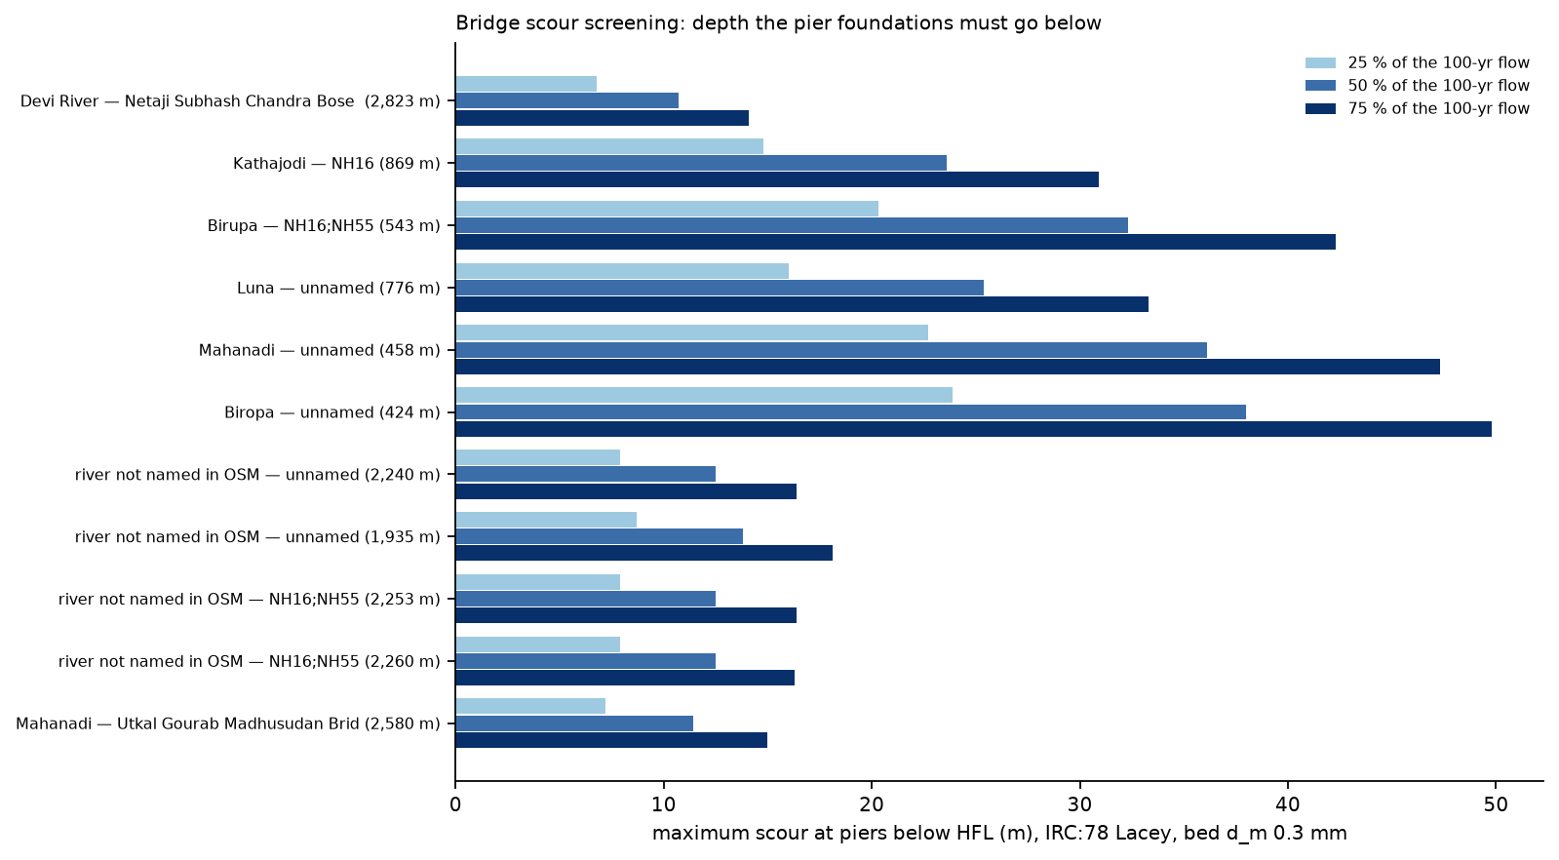
Bridge scour screening

C.4 Geotechnical: river banks
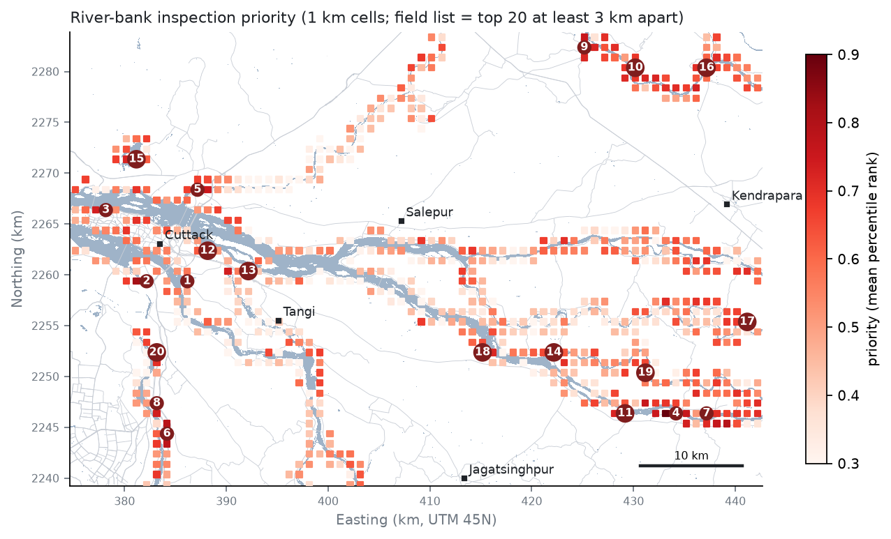
River-bank inspection priority
663 one-kilometre cells contain river bank. SoilGrids gives clay loam (456), clay (165), silty clay loam (34), silty clay (8) — too coarse to tell one bank from another, which is why the field samples matter. OpenStreetMap maps only 12 embankment segments (1.8 km), so the screening works from the river-bed outline (the WRD embankment inventory is requested in §8.1). The field list is the 20 highest cells at least 3 km apart:
Rank | Location | Water behind the bank (share of passes) | Years with water behind the bank | Texture (sand/silt/clay %) | People within 2 km
1 | 20.4290 N, 85.9090 E | 4% | 10 | clay loam (29/37/34) | 68,934
2 | 20.4290 N, 85.8710 E | 6% | 10 | clay loam (29/36/34) | 22,047
3 | 20.4920 N, 85.8320 E | 2% | 9 | clay loam (30/37/33) | 93,127
4 | 20.3140 N, 86.3690 E | 8% | 10 | clay loam (22/44/34) | 18,481
5 | 20.5110 N, 85.9180 E | 1% | 6 | clay loam (29/38/32) | 53,829
6 | 20.2940 N, 85.8910 E | 2% | 9 | clay loam (36/30/34) | 13,872
7 | 20.3140 N, 86.3980 E | 1% | 8 | clay loam (21/44/34) | 23,281
8 | 20.3210 N, 85.8810 E | 1% | 5 | clay loam (37/30/33) | 24,225
9 | 20.6390 N, 86.2820 E | 4% | 9 | clay loam (25/38/37) | 18,192
10 | 20.6210 N, 86.3300 E | 3% | 9 | clay loam (24/37/39) | 17,936
Laboratory plan: wet sieving (IS 2720 Part 4), liquid / plastic limits (IS 2720 Part 5), IS 1498 class, Kenney–Lau internal stability and a piping flag (soil_gradation.py); bank slopes measured at the site give the factor of safety dry, under seepage and after rapid drawdown (embankment_stability.py), when the river falls faster than the bank drains and the factor of safety roughly halves.

C.5 Geotechnical: ground saturation under houses that stay dry
Ground-saturation advisory
Floodwater raises the water table under the land around it. Houses that stay dry but stand on that soaked ground lose bearing capacity while it is wet and settle when the water table falls back. The advisory zone is dry land within 200 m of flood water on fine-grained soil (silt + clay ≥ 50 %, 94% of the box).
Scenario | Advisory zone (km²) | People in the zone | People on flooded land | Settlements with ≥ 25 % of people in the zone
5-year | 414 | 380,300 | 22,545 | 290
25-year | 432 | 415,549 | 25,163 | 310
100-year | 432 | 415,549 | 25,163 | 310
flooded in ≥ 10 % of passes | 319 | 299,472 | 11,063 | 185
What the advisory means for a typical house foundation (strip footing 1 m wide at 1 m depth; textbook parameters to be replaced by the lab results, foundation_checks.py):
- silty sand (φ’ = 28°): ultimate bearing capacity 415 kPa with a deep water table, 189 kPa with water at the surface (−55 %);
- clay loam, undrained: 275 kPa stiff → 172 kPa soaked (−37 %);
- when the water table falls 2 m after the flood, 4 m of soft clay consolidates by 20 to 39 mm (m_v 0.25–0.5 m²/MN) — enough to crack load-bearing masonry where it is uneven.
The 200 m distance is a screening value; the water levels in village wells at increasing distance from the flood edge (field protocol H) fix it.

C.6 Ocean engineering
Flood drivers
37 cyclones and depressions passed within 300 km of the delta since 2016 (IBTrACS). Of the 20 largest floods seen by radar, 18 came with a high Naraj flow (≥ 9,682 m³/s, the monsoon 90th percentile), 14 with heavy rain (≥ 135 mm in 7 days) and 11 within a week of a Bay of Bengal system:
Date | Flooded land (km²) | Naraj flow (m³/s) | Rain (mm) | System | Drivers
2021-09-14 | 267 | 11,614 | 231 | depression (unnamed) | river + rain + cyclone/depression
2022-08-16 | 218 | 24,603 | 177 | depression (unnamed) | river + rain + cyclone/depression
2020-08-26 | 204 | 15,523 | 187 |  | river + rain
2018-09-08 | 276 | 15,030 | 159 | depression (unnamed) | river + rain + cyclone/depression
2021-09-16 | 250 | 15,380 | 242 | depression (unnamed) | river + rain + cyclone/depression
2018-09-12 | 145 | 15,030 | 117 | depression (unnamed) | river + cyclone/depression
2021-09-19 | 182 | 15,380 | 175 | depression (unnamed) | river + rain + cyclone/depression
2026-08-14 | 138 | 9,682 | 187 |  | river + rain
2018-09-06 | 137 | 14,157 | 186 | depression (unnamed) | river + rain + cyclone/depression
2026-07-26 | 154 | 5,283 | 259 |  | rain
2026-08-02 | 121 | 14,893 | 155 |  | river + rain
2026-10-01 | 119 | 19,497 | 56 |  | river
2020-09-07 | 100 | 13,676 | 42 |  | river
2020-08-31 | 123 | 23,226 | 139 |  | river + rain
2018-10-14 | 127 | 6,901 | 145 | Titli | rain + cyclone/depression
2022-08-18 | 118 | 28,378 | 141 | depression (unnamed) | river + rain + cyclone/depression
2019-08-14 | 78 | 10,888 | 74 | depression (unnamed) | river + cyclone/depression
2025-07-31 | 72 | 16,217 | 85 | depression (unnamed) | river + cyclone/depression
2019-09-13 | 70 | 19,453 | 59 |  | river
2020-08-28 | 99 | 20,136 | 180 |  | river + rain
Systems that came within 300 km:
System | Closest | Distance (km) | Max wind near the delta (kt) | Rain that week (mm) | Max Naraj flow that week (m³/s) | Largest flood on a pass (km²)
Roanu | 2016-05-20 | 132 | 45 | 102 | 69
depression (unnamed) | 2016-08-17 | 259 | 25 | 47 | 10,398
depression (unnamed) | 2016-11-05 | 236 | 25 | 79 | 1,212
depression (unnamed) | 2017-07-18 | 99 | 25 | 89 | 6,838 | 16.4
depression (unnamed) | 2017-10-19 | 64 | 25 | 152 | 2,611 | 14.1
depression (unnamed) | 2017-11-17 | 107 | 25 | 104 | 2,957 | 8.8
depression (unnamed) | 2017-12-09 | 170 | 30 | 98 | 1,171
depression (unnamed) | 2018-07-21 | 192 | 30 | 249 | 12,444 | 68.6
depression (unnamed) | 2018-08-07 | 123 | 25 | 212 | 11,040 | 19.1
depression (unnamed) | 2018-08-15 | 52 | 25 | 103 | 13,365 | 45.8
depression (unnamed) | 2018-09-06 | 155 | 30 | 164 | 15,030 | 276.0
Daye | 2018-09-20 | 178 | 35 | 88 | 5,382 | 34.8
Titli | 2018-10-12 | 82 | 80 | 78 | 6,901 | 126.7
Fani | 2019-05-03 | 28 | 115 | 180 | 1,168
depression (unnamed) | 2019-08-07 | 140 | 30 | 133 | 11,428 | 78.1
Bulbul (Matmo) | 2019-11-09 | 154 | 75 | 43 | 1,844 | 16.3
Amphan | 2020-05-20 | 180 | 100 | 112 | 377
depression (unnamed) | 2020-10-22 | 147 | 25 | 58 | 3,040 | 21.9
Yaas | 2021-05-26 | 134 | 75 | 149 | 385
depression (unnamed) | 2021-09-13 | 64 | 30 | 227 | 15,380 | 267.3
Gulab (Shaheen) | 2021-09-26 | 217 | 45 | 52 | 6,682 | 61.8
Jawad | 2021-12-05 | 105 | 30 | 158 | 1,527
depression (unnamed) | 2022-08-09 | 67 | 25 | 193 | 24,603 | 218.4
depression (unnamed) | 2022-08-14 | 184 | 25 | 171 | 28,378 | 218.4
depression (unnamed) | 2022-08-19 | 215 | 30 | 136 | 26,914 | 64.1
depression (unnamed) | 2022-09-11 | 182 | 25 | 74 | 6,294 | 12.6
Hamoon | 2023-10-23 | 254 | 50 | 3 | 2,088 | 12.3
Midhili | 2023-11-16 | 247 | 35 | 25 | 1,261 | 9.0
depression (unnamed) | 2024-07-20 | 112 | 25 | 50 | 4,852 | 10.9
depression (unnamed) | 2024-09-09 | 52 | 30 | 52 | 19,098 | 17.7
depression (unnamed) | 2024-09-15 | 288 | 30 | 77 | 17,946 | 17.7
Dana | 2024-10-26 | 88 | 60 | 70 | 1,874 | 13.7
depression (unnamed) | 2025-05-29 | 230 | 30 | 70 | 558 | 6.7
depression (unnamed) | 2025-07-25 | 273 | 25 | 86 | 16,217 | 71.8
depression (unnamed) | 2025-08-19 | 188 | 20 | 100 | 7,655 | 30.5
depression (unnamed) | 2025-09-26 | 128 | 25 | 68 | 9,682 | 37.4
depression (unnamed) | 2025-10-02 | 181 | 30 | 120 | 11,454 | 10.0
Storm surge and high tide also slow the drainage of the lower delta through the tidal distributaries; the study box ends about 25 km inland of Paradip, and a tide-gauge record (Paradip) is the first ocean dataset to add.

C.7 Construction technology and management
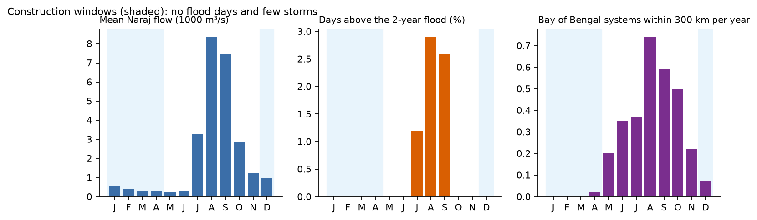
Construction windows
Month | Mean Naraj flow (m³/s) | Days above the 2-year flood | Storms within 300 km per year | Mean flooded share on radar | Work window
Jan | 569 | 0.0% | 0.00 |  | yes
Feb | 398 | 0.0% | 0.00 |  | yes
Mar | 269 | 0.0% | 0.00 |  | yes
Apr | 278 | 0.0% | 0.02 |  | yes
May | 231 | 0.0% | 0.20 |  | no
Jun | 291 | 0.0% | 0.35 | 0.2% | no
Jul | 3,274 | 1.2% | 0.37 | 0.7% | no
Aug | 8,355 | 2.9% | 0.74 | 1.5% | no
Sep | 7,465 | 2.6% | 0.59 | 1.6% | no
Oct | 2,882 | 0.0% | 0.50 | 0.7% | no
Nov | 1,210 | 0.0% | 0.22 | 0.4% | no
Dec | 965 | 0.0% | 0.07 |  | yes
Raising the critical links above the 25-year flood (raise = 90th-percentile depth + 0.6 m freeboard; crest 3.75 m single lane or 7.5 m for trunk/primary roads; side slopes 2H:1V; earthwork at an assumed ₹350/m³):
Rank | Road | Class | Flooded (km) | Depth p90 (m) | Raise (m) | Crest (m) | Design | Earthwork (m³) | Cost (₹ lakh)
1 | (unnamed) | unclassified | 1.03 | 0.6 | 1.2 | 3.75 | embankment raise | 7,601 | 26.6
2 | (unnamed) | unclassified | 0.34 | 0.4 | 1.0 | 3.75 | embankment raise | 2,008 | 7.0
3 | (unnamed) | tertiary | 0.71 | 0.0 | 0.6 | 3.75 | embankment raise | 2,109 | 7.4
4 | (unnamed) | unclassified | 0.14 | 1.6 | 2.2 | 3.75 | embankment raise | 2,599 | 9.1
5 | (unnamed) | tertiary | 0.14 | 0.7 | 1.3 | 3.75 | embankment raise | 1,206 | 4.2
6 | (unnamed) | tertiary | 2.06 | 4.3 | 4.9 | 3.75 | bridge or vented causeway | (136,774 as embankment) | –
7 | (unnamed) | unclassified | 0.34 | 0.0 | 0.6 | 3.75 | embankment raise | 1,010 | 3.5
8 | (unnamed) | residential | 0.03 | 0.2 | 0.8 | 3.75 | embankment raise | 128 | 0.4
9 | (unnamed) | tertiary | 0.31 | 3.2 | 3.9 | 3.75 | bridge or vented causeway | (13,666 as embankment) | –
10 | (unnamed) | unclassified | 0.05 | 1.4 | 2.0 | 3.75 | embankment raise | 781 | 2.7
Embankment raises for 8 links (2.78 km of road): 17,442 m³, about ₹0.61 crore. Links 6 and 9 would need raises above 3 m (4.9 m over 2.06 km; 3.9 m over 0.31 km): each needs a bridge or a vented causeway rather than a road embankment, and the DEM depth there is the first thing to check at the site (check points RL06, RL09). As embankments they alone would take 150,440 m³. Each of the ten links carries the dry-weather hospital route of 4,638–10,351 people.
Deployment quantities (quantities and effort only; the unit rates are asked from ClimMaTech):
Item | Unit | Quantity | Crew-days | Basis
Solar siren unit with controller (Rakshak-type), mast and foundation | site | 40 | 40 | 40 sirens cover 49% of the exposed people at a 1.5 km audible range (impact_siting.py)
Non-contact radar level + surface-velocity station (Pravaah-type) on bridge, with logger and telemetry | site | 6 | 12 | one per main distributary (impact_siting.py)
Cross-section and bed-material survey at each sensor bridge | site | 6 | 6 | needed to turn level + surface velocity into discharge
Community training and siren drills | village | 40 | 20 | one session per siren site
Deployment schedule
Risks: permissions for bridge mounting (PWD/NH) and siren sites (panchayat) — start in week 1; theft and vandalism of solar panels — mount high, community custody; mobile-network gaps — LoRa or satellite backhaul at the sites the field sheets flag; installation slipping into the monsoon — the window closes in May; maintenance — one pre-monsoon visit per site each year.

C.8 Water resources: the watershed above the delta
Daily GloFAS v4 flows just below Hirakud dam and at Naraj, 29 complete years between 1984 and 2025 (mahanadi/watershed_share.py). For each year the flow below Hirakud on the day before the Naraj peak is compared with the peak (one day is the travel time found in §6.5).
Year | Naraj annual peak (m³/s) | Flow below Hirakud the day before (m³/s) | Share from Hirakud
2003 | 34,673 | 27,541 | 79%
2001 | 30,619 | 14,824 | 48%
2014 | 28,906 | 13,708 | 47%
2022 | 28,378 | 15,310 | 54%
2011 | 28,118 | 14,060 | 50%
Over all 29 years the share has a median of 48% (interquartile range 30%–66%); in July–September the dam passes 60% of the mean flow at Naraj (3,803 of 6,353 m³/s). Basin areas: Hirakud controls about 83,400 km² of a basin of about 141,600 km² (sources differ between about 139,700 and 141,600 km²). GloFAS represents the reservoir with a generic operating rule, so these shares are indicative until CWC/WRD gauge and release records replace them.

Appendix D. Reproducing every result
Everything runs from the scripts in this folder; the lab server holds the data (/home1/vineet/floodfm) and the laptop builds the documents. Each stage writes files that the next one reads.
Stage | Scripts | Writes
Benchmark data | scripts/build_cache.py, server/get_data.sh | Sen1Floods11 cache (446 chips)
Benchmark training | floodfm/train.py through scripts/jobqueue.py server/jobs_main.txt | 92 runs, each with results.json and predictions
Benchmark analysis | scripts/analyze.py, scripts/make_tables.py, scripts/eval_no_training.py | tables, figures, thresholds, fusion
Training audit | scripts/audit_training.py | results/analysis/audit_training.json (Appendix A)
20 m retraining | floodfm/train.py --s1_res 20 (server/jobs_r20.txt), scripts/test_resolution.py | results/analysis/radar20m_r20.json (Appendix B)
Context layers | mahanadi/fetch_context.py, fetch_osm_pbf.py | discharge, rain, OpenStreetMap, population, land cover, DEM, soils, storm tracks
Radar archive | mahanadi/atlas_pull.py | 590 Sentinel-1 passes at 20 m
Water maps | mahanadi/atlas_infer.py | 1,180 probability maps
Atlas, trigger map, validation, design floods | mahanadi/atlas_build.py | results/atlas/
Learned flood model | mahanadi/learned_flood_model.py | results/atlas/learned/
Impacts and siting | mahanadi/impact_exposure.py, impact_transport.py, impact_siting.py, impact_geotech.py, impact_depth.py, impact_structures.py, impact_ground.py, ocean_cyclones.py, cm_plan.py, watershed_share.py, travel_time.py | results/impact/
Independent check | mahanadi/s2_crosscheck.py | results/impact/s2_crosscheck.json
Bulletins and CAP alerts | mahanadi/forecast_to_impact.py | results/impact/bulletins/
Field check points, figures, viewer | mahanadi/make_checkpoints.py, make_atlas_figures.py, make_discipline_figures.py, make_dashboard.py | fieldkit/checkpoints/, results/atlas_figures/, dashboard/index.html
Whole chain on the server | mahanadi/run_atlas_pipeline.sh, run_disciplines.sh (SKIP_BUILD=1 SKIP_S2=1 re-runs only the impacts) | all of the above
Documents | report/write_sections.py, build_report.py, build_slides.py, build_website.py | this report, the slides, the website
The exact commands are in README.md. Every number in this report is read from these files when the report is built, so a re-run updates the text, the tables, the slides and the website together.

Appendix E. Glossary
Term | Meaning in this report
Sentinel-1 | European radar satellites; the radar sees the ground through cloud, and calm water looks dark because it reflects the signal away
Sentinel-2 | European optical satellites (like a camera with extra colours); blocked by cloud
VV, VH | The two radar polarisations Sentinel-1 records
RTC, γ⁰, σ⁰ | Radiometric terrain correction, and two conventions for radar brightness; the atlas converts γ⁰ to σ⁰ to match the training data
Sen1Floods11 | A public set of 446 hand-labelled flood images from 11 floods, used to train and test the models
Foundation model | A large network pre-trained on millions of unlabelled satellite images, then fine-tuned for a task (Prithvi, TerraMind, DOFA, Clay, Satlas, DeCUR)
Fine-tuned, frozen | Fine-tuned: every weight is trained further; frozen: the pre-trained encoder is kept and only the decoder learns
U-Net, CNN | Small convolutional networks trained from scratch, the baselines
Fusion | Combining the predictions of several models (mean, weighted or a learned layer)
Leave-India-out | Training without any Indian image and testing on the Assam 2016 flood, so the test flood is unseen
IoU | Intersection over union: overlap between predicted and true water divided by their union (1 = perfect)
mIoU | Mean of the IoU for water and for dry land, the metric of the foundation-model papers
Precision, recall | Of the pixels called water, the share that is water; of the true water, the share that was found
POD, FAR, CSI | For villages: probability of detection, false-alarm ratio, critical success index (hits over hits + misses + false alarms)
ROC AUC | How well a map ranks flooded land above dry land (0.5 = chance, 1 = perfect)
GloFAS | Global Flood Awareness System; modelled daily river flow, used here at Naraj, Tikarpara and below Hirakud
ERA5 | A global weather reanalysis; daily rain over the delta
Trigger discharge | For each 20 m pixel, the Naraj flow above which it is usually flooded
Flood climatology, frequency | How often a pixel was flooded on past passes
Analog map | The flood seen on past passes with a similar flow (and rain)
Leave-one-year-out | Each year is predicted by a model fitted on the other years only
Return period, Gumbel | A T-year flood is exceeded on average once in T years; the Gumbel distribution is fitted to yearly maxima to estimate it
Lakh cusec | 100,000 cubic feet per second, about 2,832 m³/s; the unit of Odisha flood bulletins
HFL | High flood level
Scour | Erosion of the river bed around bridge piers and abutments during a flood
IRC:78, IRC:5 | Indian Roads Congress codes for bridge foundations (scour) and bridge design (clearance)
Bearing capacity | The load a soil can carry under a footing; it drops when the soil is saturated
Rapid drawdown | A river falling faster than its bank drains, the condition in which banks most often slide
IBTrACS | International record of tropical cyclone tracks
CAP | Common Alerting Protocol, the standard format for warnings that the Rakshak Control Centre accepts
PINN | Physics-informed neural network; here trained to satisfy the Saint-Venant equations of river flow

